

REPORT TITLE

ANDROID APPLICATION FOR AMAR SINGH COLLEGE

Submitted by:

1} M.Umer Ali {Team Leader} (2553)

2} Faiz Ul Islam (2561)

3} Zaid Majeed Reshi (2530)

4} Suhail Qadir Beigh (2510)

Batch :- 2016

Session :- 2019-2020

**August 18** 2019





Developed Under The

Guidance of

Prof. ***Rashid Malik***

SUBMITTED IN COMPELTE FULFILLMENT FOR

THE AWARD OF THE DEGREE OF

BACHELOR OF COMPUTER APPLICATION

|  |
| --- |
|  |

Certificate

This is to certify that the software project report entitled “**ANDROID APPLICATION FOR AMAR SINGH COLLEGE "** submitted by M.Umer Ali, Faiz Ul Islam, Zaid Majeed Reshi, Suhail Qadir Beigh has been carried out under my guidance and supervision. The project report is approved for submission towards complete fulfilment of the requirement for the award of degree of **BACHELORS IN COMPUTER APPLICATIONS** from Amar Singh College in affiliation with University of Kashmir Srinagar.

Internal Guide H.O.D

Prof. Rashid Malik. Prof. Asif Kawoosa.

Declaration

We hereby declare that the project entitled “**ANDROID APPLICATION FOR AMAR SINGH COLLEGE "** which being submitted in the complete fulfilment of (he requirement for award for the degree of BACHELORS IN COMPUTER APPLICATIONS to the DEPARTMENT OF COMPUTER APPLICATIONS, AMAR SINGH COLLEGE is an authentic record of our own work done under the guidance of Prof. Rashid Malik.

The matter reported in this project has not been submitted earlier for the award of any other degree.

1. M.Umer Ali (Team leader). **ROLL NO**: 2553.
2. Faiz-ul-islam. **ROLL NO**: 2561.
3. Zaid Majeed Reshi. **ROLL NO**: 2535.
4. Suhail Qadir Beigh **ROLL NO**: 2510.

Acknowledgment

We sincerely express indebtedness to our esteemed and revered faculty members, project guide and head of the department of computer applications of Amar Singh College for their invaluable guidance, support, assistance, comments, supervision, and encouragement throughout the work. Without his kind patronage and guidance, the project would not have taken shape.

We owe a deepest sense of gratitude and obligation to our Honourable Head of Department "Prof. Asif ", for his constant encouragement and kind approval. We would like to express our sincere regards to him for advice and counselling from time to time.

We owe sincere thanks to the College Faculty whose moral support, continuous patience and keen personal interest have been instrumented in making this project work possible.

INDEX

TABLE OF CONTENTS PAGE NO.

l. Introduction

1.1. Abstract 08

1.2. Project Objective And Problem Definition 09

1.3. Introduction to Android 10

2. Environmental Specifications 16

2.1. Software Specifications 16

2.2. Technological Specifications 16

2.3. Hardware Specifications 16

3. Architecture 17

3.1. System Architecture 17

3.2. Basic Concept 17

3.3. Architecture Diagram 18

4. System Analysis 19

4.1. Proposed System 19

4.2. Feasibility Study 20

4.3. Technical Feasibility 20

4.4. Economical Feasibility 21

4.5. Behaviour Feasibility 22

5. System Design 23

5.1. Input Design 23

5.2. Output Design 24

6. Testing 25

6.1. White Box Testing 25

6.2. Black Box Testing 25

6.3. Levels of Testing 26

6.4. Unit Testing 26

6.5. Test Cases 28

7. Snapshots with Code 29

8.DFD 95

10. Bibliography 96

Abstract

The application can be used by the college to make it easier for the residing students to access information regarding their syllabus, notifications and events of the college and faculty, courses offered, syllabus, academic calendar, campus map for the new students and higher secondary pass outs.

Project objectives

The main objective of the application is to offer information related to college to the residing students, new students and higher secondary pass outs who are looking for colleges.

**PROBLEM DEFINITION:**

* Notification and events that are circulated manually and are only present on website of the college will now be available on the android application.
* New students will get introduced to the various facilities of the college from the application without looking for a prospectus on the website.
* New students can locate the departments and office with the help of campus map in the application without going back to the main gate to look it up from the campus map installed there or asking others.
* New students will get introduced to their respective faculty and principal and can get their contact information from the application.
* All the students can download the syllabus of their respective semesters from the application without going to the website to download it.
* This application will help out in the decision making of the higher secondary pass outs by providing information regarding the college.

Introduction to Android:

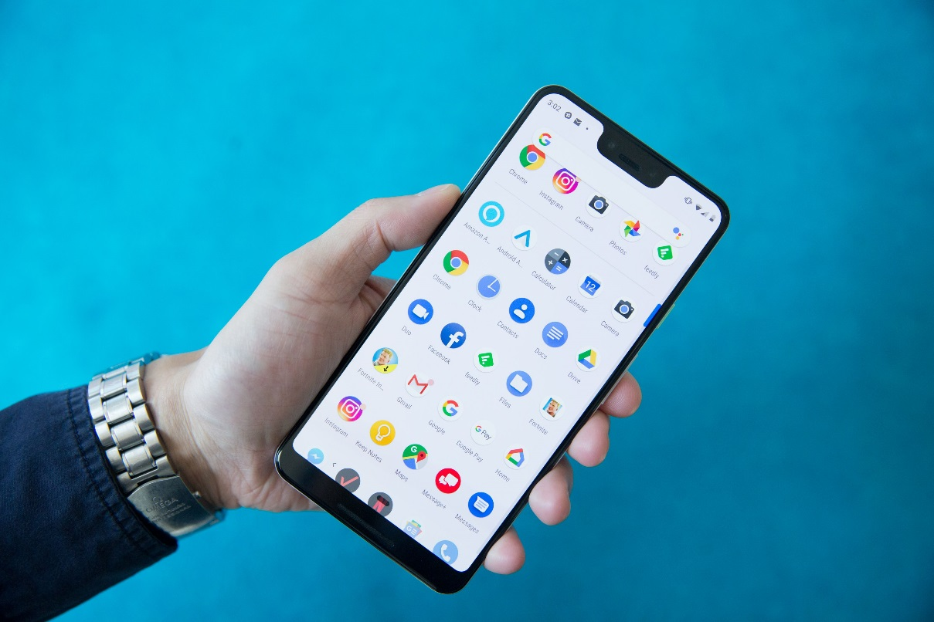

Android is a mobile operating system (OS) based on the Linux kernel and currently developed by Google. With a user interface based on direct manipulation, Android is designed primarily for touchscreen mobile devices such as smartphones and tablet computers, with specialized user interfaces for televisions (Android TV), cars (Android Auto), and wrist watches (Android Wear). The OS uses touch inputs that loosely correspond to real-world actions, like swiping, tapping, pinching, and reverse pinching to manipulate on-screen objects, and a virtual keyboard. Despite being primarily designed for touchscreen input, it also has been used in game consoles, digital cameras, regular PCs (e.g. the I-IP Slate 21) and other electronics.

Android is the most widely used mobile OS and, as of 2013, the highest selling OS overall. Android devices sell more than Windows, iOS, and Mac OS X devices combined, with sales in 2012, 2013 and 2014 close to the installed base of all PCs.As of July 2013 the Google Play store has had over I million Android apps published, and over 50 billion apps downloaded. A developer survey conducted in April—May 2013 found that 71%

of mobile developers develop for Android. At Google I/0 2014, the company revealed that there were over 1 billion active monthly Android users, up from 538 million in June 2013. Android's source code is released by Google under open source licenses, although most Android devices ultimately ship with a combination of open source and proprietary software. Initially developed by Android, Inc., which Google backed financially and later bought in 2005, Android was unveiled in 2007 along with the founding of the Open Handset Alliance—a consortium of hardware, software, and telecommunication companies devoted to advancing open standards for mobile devices.

Android is popular with technology companies which require a readymade, low-cost and customizable operating system for high tech devices. Android's open nature has encouraged a large community of developers and enthusiasts to use the open-source code as a foundation for community-driven projects, which add new features for advanced users or bring Android to devices which were officially released running other operating systems. The operating system's success has made it a target for patent litigation as part of the so-called "smartphone wars" between technology companies.

***Interface***

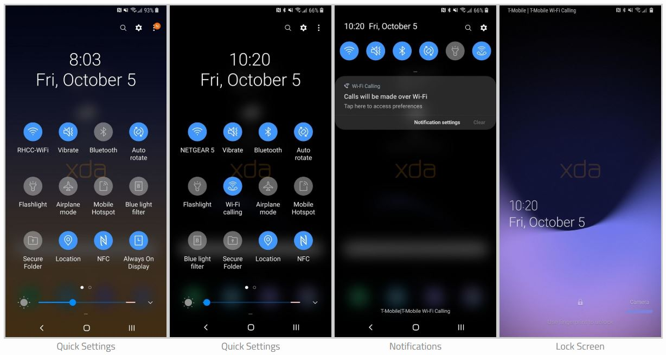

Android’s default user interface is based on direct manipulation, using touch inputs, that loosely correspond to real-world actions, like swiping, tapping, pinching, and reverse pinching to manipulate on-screen objects, and a virtual keyboard. The response to user input is designed to be immediate and provides a fluid touch interface, often using the vibration capabilities of the device to provide haptic feedback to the user. Internal hardware such as accelerometers, gyroscopes and proximity sensors are used by some applications to respond to additional user actions, for example adjusting the screen from portrait to landscape depending on how the device is oriented, or allowing the user to steer a vehicle in a racing game by rotating the device, simulating control of a steering wheel.

Android devices boot to the home screen, the primary navigation and information point on the device, which is similar to the desktop found on PCs. Android home screens are typically made up of app icons and widgets; app icons launch the associated app, whereas widgets display live, auto-updating content such as the email inbox, or a news ticker directly on the weather forecast, the user's home screen. A home screen may be made up of several pages that the user can swipe back and forth between, though Android's home screen interface is heavily customizable, allowing the user to adjust the look and feel of the device to their tastes. Third-party apps available on Google Play and other app stores can extensively re-theme the home screen, and even mimic the look of other operating systems, such as Windows Phone. Most manufacturers, and some wireless carriers, customize the look and feel of their Android devices to differentiate themselves from their competitors. Present along the top of the screen is a status bar, showing information about the device and its connectivity. This status bar can be "pulled" down to reveal a notification screen where apps display important information or updates, such as a newly received email or SMS text, in a way that does not immediately interrupt or inconvenience the user. Notifications are persistent until read (by tapping, which opens the relevant app) or dismissed by sliding it off the screen. Beginning on Android 4.1, "expanded notifications" can display expanded details or additional functionality; for instance, a music player can display playback controls, and a "missed call" notification provides buttons for calling back or sending the caller an SMS message.

Android provides the ability to run applications which change the default launcher and hence the appearance and externally visible behaviour of Android. These appearance changes include a multi-page dock or no dock, and many more changes to fundamental features of the user interface.

Memory management

Since Android devices are usually battery-powered, Android is designed to manage memory (RAM) to keep power consumption at a minimum, in contrast to desktop operating systems which generally assume they are connected to unlimited mains electricity. When an Android application is no longer in use, the system will automatically suspend it in memory; while the application is still technically 'open", suspended applications consume no resources (for example, battery power or processing power) and sit idly in the background until needed again. This brings a dual benefit by increasing the general responsiveness of Android devices, since applications do not need to be closed and reopened from scratch each time, and by ensuring that background applications do not consume power needlessly.

Android manages the applications stored in memory automatically: when memory is low, the system will begin killing applications and processes that have been inactive for a while, in reverse order since they were last used (oldest first). This process is designed to be invisible to the user, so that users do not need to manage memory or the killing of applications themselves. However, confusion over Android's memory management resulted at some point in time in third-patty task killers becoming popular on Google Play store; these third-party task killers are generally regarded as doing more harm than good.

Hardware

The main hardware platform for Android is the ARM architecture (ARMv7 or later, Android 5.0 also supports ARMv8-A), with x86 and MIPS architectures also officially supported. Both 64bit and 32-bit variants of all three architectures are supported since the release of Android 5.0. Since 2012, Android devices with Intel processors began to appear, including phones and tablets.

As of November 2013, Android 4.4 recommends at least 512 of RAM, while for "low RAM" devices 340 MB is the required minimum amount that does not include memory dedicated to various hardware components such as the baseband processor. Android 4.4 requires a 32bit ARMv7, MIPS or x86 architecture processor (latter two through unofficial ports), together with an OpenGL ES 2.0 compatible graphics processing unit (GPU). Android supports OpenGL ES 1.1,2.0, 3.0 and 3.1. Some applications may explicitly require a certain version of the OpenGL ES, and suitable GPU hardware is required to run such applications, Android devices incorporate many optional hardware components, including still or video cameras, GPS, orientation sensors, dedicated gaming controls, accelerometers, _gyroscopes, barometers, magnetometers, proximity sensors, pressure sensors, thermometers, and touchscreens.

Some hardware components are not required, but became standard in certain classes of devices, such as smartphones, and additional requirements apply if they are present. Some other hardware was initially required, but those requirements have been relaxed or eliminated altogether. For example, as Android was developed initially as a phone OS, hardware such as microphones were required, while over time the phone function became optional. Android used to require an autofocus camera, which was relaxed to a fixed focus camera if it is even present at all, since the camera was dropped as a requirement entirely when Android started to be used on set-top boxes. In addition to running on smartphones and tablets, several vendors run Android natively on regular PC hardware with a keyboard and mouse. In addition to their availability on commercially available hardware, similar PC hardware— friendly versions of Android are freely available from the Android-x86 project, including customized Android 4.4. Using the Android emulator that is part of the Android SDK, or by using Blue Stacks or Andy, Android can also run non- natively on x86. Chinese companies are building a PC and mobile operating system, based on Android, to "compete directly with Microsoft Windows and Google Android". The Chinese Academy of Engineering noted that "more than a dozen" companies were customizing Android following a Chinese ban on the use of Windows 8 on government PCs.

Software Stack

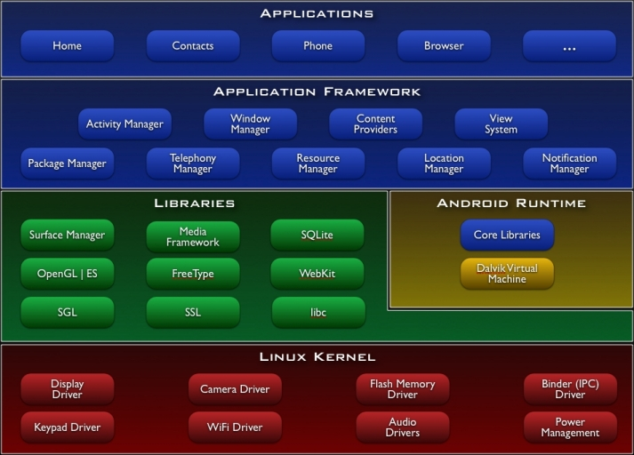

Android's architecture diagram

On top of the Linux kernel, there the middleware, libraries and APIs written in C, and application software running on an application framework which includes Java

compatible libraries based on Apache Harmony. Development of the Linux kernel continues independently of other Android's source code bases. Android uses the Dalvik virtual machine with just-in-time compilation (JIT) to run Dalvik "dex- code" (Dalvik Executable), which is usually translated from the Java by tecode. Android 4.4 also supports new experimental runtime, Android Runtime (ART), which is not enabled by default.

Android's standard C library, Bionic, was developed by Google specifically for Android, as a derivation of the BSDs standard C library code. Bionic itself has been designed with several major features specific to the Linux kernel. The main benefits of using Bionic instead of the GNU C Library (glibc) or uClibcare its different licensing model, smaller runtime footprint, and optimization for low- frequency CPUs.

Aiming for a more suitable licensing model, toward the end of 2012 Google switched the Bluetooth stack in Android from the GPLlicensed BlueZ to the Apache-licensed BlueDroid.

Android does not have a native X Window System by default, nor does it support the full set of standard GNU libraries. This made it difficult to port existing Linux applications or libraries to Android, until version r5 of the Android Native Development Kit brought support for applications written completely in C or C4+. Libraries written in C may also be used in Java application by injection of a small Java shim and usage of the JNI.

ENVIRONMENTAL SPECIFICATIONS

HARDWARE SPECIFICATIONS

* 1.6 GHz Octa Core Processor or above.
* 3 GB RAM or above.
* 8 GB Storage or above.

SOFTWARE SPECIFICATIONS

* Android 8.0.0 Oreo (API level 26) or above.

TECHNOLOGICAL SPECIFICATIONS

* Android studio.
* My SQL.
* PHP.
* Apache HTTP Server.

APIs USED:

* Retrofit.
* Picasso.

ARCHITECTURE

System architecture

3-tier application architecture is organized into three major disjunctive tiers on layers. Here we can see that how these layers increase the reusability of codes.

These layers are described below.

1. Application layer or Business layer.

2. Business layer.

3. Data Access layer.

1. Application layer or Presentation layer: -

Application layer is the form which provides the user interface to either programmer of end user. Programmer uses this layer for designing purpose and to get or set the data back and forth.

2. Business layer: -

This layer is a class which we use to write the function which works as a mediator to transfer the data from Application or presentation layer data layer. In the three-tier architecture we never let the data access layer to interact with the presentation layer. Business layer deals with validation and workflow.

3. Data Access Layer: -

This layer is also a class which we use to get or set the data to the database back and forth. This layer only interacts with the database. We write the database queries or use stored procedures to access the data from the database or to perform any operation to the database.

Summary :

Form or the project Class Class

Data Layer or Data Access Layer

Layet

Application or Presentation Layer

Business Layer or Logical Layer

Class

Business Layer or Logical Layer

* Application layer is the form where we design using the controls like textbox, labels, command buttons etc.

* Business layer is the class where we write the functions which get the data from the application layer and passes through the data access layer.

* Data layer is also the class which gets the data from the business layer and sends it to the database or gets the data from the database and sends it to the business layer.
* Property layer is the sub-layer of the business layer in which we make the properties to set or get the values from the application layer. These properties help to sustain the value in an object so that we can get these values till the object destroys.

SYSTEM ANALYSIS

Introduction to System Analysis

System analysis is a process of gathering and interpreting facts, diagnosing problems and the information to recommend improvements on the system. It is a problem-solving activity that requires intensive communication between the system users and system developers. System analysis or study is an important phase of any system development process. The system is studied to the minutest detail and analysed. The system analyst plays the role of the interrogator and dwells deep into the working of the present system. The system is viewed as a whole and the input to the system are identified. The outputs from the organizations are traced to the various processes. System analysis is concerned with becoming aware of the problem, identifying the relevant and decisional variables, analysing and synthesizing the various factors and determining an optimal or at least a satisfactory solution or program of action. A detailed study of the process must be made by various techniques like interviews, questionnaires etc. The data collected by these sources must be scrutinized to arrive to a conclusion. The conclusion is an understanding of how the system functions. This system is called the existing system. Now the existing system is subjected to close study and problem areas are identified. The designer now functions as a problem solver and tries to sort out the difficulties that the enterprise faces. The solutions are given as proposals. The proposal is then weighed with the existing system analytically and the best one is selected. The proposal is presented to the user for an endorsement by the user. The proposal is reviewed on user request and suitable changes are This is loop that ends as soon as the user is satisfied with proposal.

Preliminary study is the process of gathering and interpreting facts, using the information for further studies on the system. Preliminary study is

problem solving activity that requires intensive communication between the system users and system developers. It does various feasibility studies. In these studies, a rough figure of the system activities can be obtained, from which the decision about the strategies to be followed for effective system study and analysis can be taken.

FEASIBILITY STUDY

Feasibility study is made to see if the project on completion will serve the purpose of the organization for the amount of work, effort and the time that spend on it. Feasibility study lets the developer foresee the future of the project and the usefulness. A feasibility study of a system proposal is according to its workability, which is the impact on the organization, ability to meet their user needs and effective use of resources. Thus when a new application is proposed it normally goes through a feasibility study before it is approved for development.

The document provide the feasibility of the project that is being designed and lists various areas that were considered very carefully during the feasibility study of this project such- as Technical, Economic and Operational feasibilities. The following are its features:

TECHNICAL FEASBLITY

The system must be evaluated from the technical point of view first. The assessment of this feasibility must be based on an outline design of the system requirement in the terms of input, output, programs and procedures, Having identified an outline system, the investigation must go on to suggest

the type of equipment, required method developing the system, of running the system once it has been designed.

Technical issues raised during the investigation are:

* Does the existing technology sufficient for the suggested one?
* Can the system expand if developed?

The project should be developed such that the necessary functions and performance are achieved within the constraints. The project is developed within latest technology. Through the technology may become obsolete after some period of time, due to the fact that never version of same software supports older versions, the system may still be used. So, there are minimal constraints involved with this project. The system has been developed using Java the project is technically feasible for development.

ECONOMIC FEASIBILITY

The developing system must be justified by cost and benefit. Criteria to ensure that effort is concentrated on project, which will give best, return at the earliest. One of the factors, which affect the development of a new system, is the cost it would require.

The following are some of the important financial questions asked during preliminary investigation:

* The costs conduct a full system investigation.
* The cost of the hardware and software.
* The benefits in the form of reduced costs or fewer costly errors.

Since the system is developed as part of project work, there is no manual cost to spend for the proposed system. Also all the resources are already available, it give an indication of the system is economically possible for development.

BEHAVIORAL FEASIBILITY

This includes the following questions:

* Is there sufficient support for the users?
* Will the proposed system cause harm?

The project would be beneficial because it satisfies the objectives when developed and installed. All behavioural aspects are considered carefully and conclude that the project is behaviourally feasible.

SYSTEM DESIGN

Introduction to System Design

Design is the first step into the development phase for any engineered product or system. Design is a creative process. A good design is the key to effective system. The term “design" is defined as "the process of applying various techniques and principles for the purpose of defining a process or a system in sufficient detail to permit its physical realization". It may be defined as a process of applying various techniques and principles for the purpose of defining a device, a process or a system in sufficient detail to permit its physical realization.

Software design sits at the technical kernel of the software engineering process and is applied regardless of the development paradigm that is used. The system design develops the architectural detail required to build a system or product. As in the case of any systematic approach, this software too has undergone the best possible design phase fine tuning all efficiency, performance and accuracy levels. The design phase is a transition from a user-oriented document to a document to the programmers or database personnel. System design goes through two phases of development: Logical and Physical Design.

Input design

The design of input focuses on controlling the amount of input required, controlling the errors, avoiding delay, avoiding extra steps and keeping the process simple. The input is designed in such a way so that it provides security and ease of use with retaining the' privacy. Input Design considered the following things:

* What data should be given as input?
* How the data should be arranged or coded?
* The dialog to guide the operating personnel in providing input,
* Methods for preparing input validations and steps to follow when error occur.

OUTPUT DESIGN

A quality output is one, which meets the requirements of the end user and presents the information clearly. In output design it is determined how the information is to be displaced for immediate need and also the hard copy output. It is the most important and direct source information to the user.

Efficient and intelligent output design improves the system's relationship to help user decision-making.

Designing computer output should proceed in an organized, well thought out manner; the right output must be developed while ensuring that each output element is designed so that people will find the system can use easily and effectively. When analysis design computer output, they should:

* Identify the specific output that is needed to meet the requirements.
* Select methods for presenting information.
* Create document, report, or other formats that contain information produced by the system.

Testing

Testing is the process of detecting errors. Testing performs a very critical role for quality assurance and for ensuring the reliability of software. The results of testing are used later during maintenance also. The aim of testing is to make sure that the software works correctly by showing that it has no errors. The basic purpose of testing phase is to detect the errors that may be present if any. The main objective of testing is to uncover a host of errors, systematically and with minimum effort and time. Five basic principles of testing are:

* Testing is a process of executing a program with the intent of finding an error in the software.
* A successful test is one that uncovers an as yet undiscovered error.
* A good test case is one that has a high probability of finding error, if it exists.
* The tests are inadequate to detect possibly present errors; it can only show that the software error is present.
* The software more or less confirms to the quality and reliable standards.

To accomplish testing process, we have used two approaches of testing:

**1.White Box Testing:** This is a unit testing method where a unit will be taken at a time and tested at a statement level to find errors. We tested step every piece of code, taking care that every statement in the code is executed at least once. It is also called Glass Box Testing. We generated test cases used to check all possible combinations of execution paths through the code at every module level.

**2.Black Box Testing:** This testing considers a module as a single unit and checks the unit at interface and its communication with other modules rather getting into details at statement level. Here the module will be treated as a block box that will take inputs and generate output. Output for a given set of input combinations are forwarded to other modules.

* **Alpha Testing:** -A series of Acceptance tests were conducted by the end user. Their suggestions were included in the project.
* **Beta Testing: -**It is to be conducted by the end user without the presence of the developer,

Levels of Testing:

In order to uncover the errors present in different phases we have the concept of levels of testing. The basic levels of testing are:

**Client Needs** **Acceptance Testing**

Testing Requirements System

Design Integration Testing

Code Unit Testing

Unit Testing

Unit testing focuses verification effort on the smallest unit of software i.e. the module. Using the detailed design and the process specifications testing is done to uncover errors within the boundary of the module. All modules must be successful in the unit test before the start of the integration testing begins.

In this project each service can be thought of a module. There are so many modules like Blog, Job Search, Music Download, News Updates Section, Online Poll and Stock. Each module has been tested by giving different sets of inputs so that each module works without any error. The inputs are validated when accepting from the user.

Integration testing:

After the unit testing we have to perform integration testing. The goal here is to see if modules can be integrated properly, the emphasis being on testing interfaces between modules. This testing activity can be considered as testing the design and hence the emphasis on testing module interactions. In this project the main system is formed by integrating all the modules. When integrating all the modules I have checked whether the integration effects working of any of the services by giving different combinations of inputs with which the two services run perfectly before Integration.

System testing:

Here the entire software system is tested. The reference document for this process is the requirements document, and the goal to see if software meets its requirements. Here entire 'Android Application for Amar Singh College' has been tested against requirements of project and it is checked whether all requirements of project have been satisfied or not.

Acceptance testing:

Acceptance Test is performed with realistic data of the client to demonstrate that the software is working satisfactorily. Testing here is focused on external behaviour of the system; the internal logic of program is not emphasized.

Test cases should be selected so that the largest number of attributes of an equivalence class is exercised at once. The testing phase is an important part of software development. It is the process of finding errors and missing operations and also a complete verification to determine whether the objectives are met and the user requirements are satisfied.

TEST CASES:

A test-case is simply a test with formal steps and instructions; test cases are valuable because they are repeatable, reproducible under the same environments, and easy to improve upon with feedback. A test-case is the difference between saying that something seems to be working okay and proving that a set of specific tasks to make sure that it really is working correctly. A test-case is a series of explicit actions and examinations that identifies the "what".

We developed test-cases for testing each module independently. We developed test-cases for testing user logins, registration, uploading, and resume submission in job search module. We checked blog module, music download, poll etc. along with each and every navigation link present. We tested each and every page, especially those that are related to user management and control.

Code & Screen Shorts

Code

Front end:

1. Activities. 1.0-1.3

2. Fragments. 2.0-2.6

3. Recyclers. 3.0-3.2

4. Retrofit. 4.0-4.4

(i) Models.

(ii) Interface.

(iii) Client

5. Layouts. 5.0-9.3

Back End:

1.PHP. 6.0-6.3

2.Database Views structure 7.0-7.2

Activities

1.0 Main Activity

**package** com.example.mumerali.asc.Activities;  
  
**import** android.os.Bundle;  
**import** com.example.mumerali.asc.Fragments.AboutApp;  
**import** com.example.mumerali.asc.Fragments.AboutCollege;  
**import** com.example.mumerali.asc.Fragments.Courses;  
**import** com.example.mumerali.asc.Fragments.Maps;  
**import** com.example.mumerali.asc.Fragments.News;  
**import** com.example.mumerali.asc.Fragments.People;  
**import** com.example.mumerali.asc.R;  
**import** com.example.mumerali.asc.Fragments.Syllabus;  
**import** com.google.android.material.navigation.NavigationView;  
**import** androidx.core.view.GravityCompat;  
**import** androidx.drawerlayout.widget.DrawerLayout;  
**import** androidx.appcompat.app.ActionBarDrawerToggle;  
**import** androidx.appcompat.app.AppCompatActivity;  
**import** androidx.appcompat.widget.Toolbar;  
**import** android.view.Menu;  
**import** android.view.MenuItem;  
  
**public class** MainActivity **extends** AppCompatActivity  
 **implements** NavigationView.OnNavigationItemSelectedListener {  
  
 @Override  
 **protected void** onCreate(Bundle savedInstanceState) {  
 **super**.onCreate(savedInstanceState);  
 setContentView(R.layout.***activity_main***);  
 Toolbar toolbar = (Toolbar) findViewById(R.id.***toolbar***);  
 setSupportActionBar(toolbar);  
  
 DrawerLayout drawer = (DrawerLayout) findViewById(R.id.***drawer_layout***);  
 ActionBarDrawerToggle toggle = **new** ActionBarDrawerToggle(**this**, drawer, toolbar, R.string.***navigation_drawer_open***, R.string.***navigation_drawer_close***);  
 drawer.addDrawerListener(toggle);  
 toggle.syncState();  
  
 NavigationView navigationView = (NavigationView) findViewById(R.id.***nav_view***);  
 navigationView.setNavigationItemSelectedListener(**this**);  
 getSupportFragmentManager().beginTransaction().replace(R.id.***content_frame***, **new** News()).commit();  
 }  
  
 @Override  
 **public void** onBackPressed() {  
 DrawerLayout drawer = (DrawerLayout) findViewById(R.id.***drawer_layout***);  
 **if** (drawer.isDrawerOpen(GravityCompat.***START***)) {  
 drawer.closeDrawer(GravityCompat.***START***);  
 } **else** {  
 **super**.onBackPressed();  
 }  
 }  
  
 @Override  
 **public boolean** onCreateOptionsMenu(Menu menu) {  
 *// Inflate the menu; this adds items to the action bar if it is present.* getMenuInflater().inflate(R.menu.***main***, menu);  
 **return true**;  
 }  
  
 @Override  
 **public boolean** onOptionsItemSelected(MenuItem item) {  
 *// Handle action bar item clicks here. The action bar will  
 // automatically handle clicks on the Home/Up button, so long  
 // as you specify a parent activity in AndroidManifest.xml.* **int** id = item.getItemId();  
  
 *//noinspection SimplifiableIfStatement* **if** (id == R.id.***action_settings***) {  
 **return true**;  
 }  
  
 **return super**.onOptionsItemSelected(item);  
 }  
  
  
 @SuppressWarnings(**"StatementWithEmptyBody"**)  
 @Override  
 **public boolean** onNavigationItemSelected(MenuItem item) {  
 *// Handle navigation view item clicks here.* **int** id = item.getItemId();  
  
 **if** (id == R.id.***nav_syllabus***) {  
 *// Handle the camera action* getSupportFragmentManager().beginTransaction().replace(R.id.***content_frame***, **new** Syllabus()).commit();  
 }  
  
 **if** (id == R.id.***nav_faculty***) {  
 *// Handle the camera action* getSupportFragmentManager().beginTransaction().replace(R.id.***content_frame***, **new** People()).commit();  
 }  
 **if** (id == R.id.***nav_map***) {  
 *// Handle the camera action* getSupportFragmentManager().beginTransaction().replace(R.id.***content_frame***, **new** Maps()).commit();  
 }  
 **if** (id == R.id.***nav_courses***) {  
 *// Handle the camera action* getSupportFragmentManager().beginTransaction().replace(R.id.***content_frame***, **new** Courses()).commit();  
 }  
 **if** (id == R.id.***nav_aboutcollege***) {  
 *// Handle the camera action* getSupportFragmentManager().beginTransaction().replace(R.id.***content_frame***, **new** AboutCollege()).commit();  
 }  
 **if** (id == R.id.***nav_news***) {  
 *// Handle the camera action* getSupportFragmentManager().beginTransaction().replace(R.id.***content_frame***, **new** News()).commit();  
 }  
 **if** (id == R.id.***nav_aboutapp***) {  
 *// Handle the camera action* getSupportFragmentManager().beginTransaction().replace(R.id.***content_frame***, **new** AboutApp()).commit();  
 }  
 DrawerLayout drawer = (DrawerLayout) findViewById(R.id.***drawer_layout***);  
 drawer.closeDrawer(GravityCompat.***START***);  
 **return true**;  
 }  
}

1.1 Course Activity

**package** com.example.mumerali.asc.Activities;  
  
**import** android.content.Context;  
**import** android.content.Intent;  
**import** android.os.Bundle;  
**import** com.example.mumerali.asc.R;  
**import** com.example.mumerali.asc.Retrofit.Client.ApiClient;  
**import** com.example.mumerali.asc.Retrofit.Interface.ApiInterface;  
**import** com.example.mumerali.asc.Retrofit.Models.CoursesOffered;  
**import** com.example.mumerali.asc.Recyclers.RecyclerAdapterIII;  
**import** androidx.appcompat.app.AppCompatActivity;  
**import** androidx.recyclerview.widget.LinearLayoutManager;  
**import** androidx.recyclerview.widget.RecyclerView;  
**import** java.util.List;  
**import** retrofit2.Call;  
**import** retrofit2.Callback;  
**import** retrofit2.Response;  
  
**public class** CourseActivity **extends** AppCompatActivity {  
  
 **private** RecyclerView **recyclerView**;  
 **private** RecyclerView.LayoutManager **layoutManager**;  
 **private** List<CoursesOffered> **coursesOffered**;  
 **private** RecyclerAdapterIII **adapter**;  
 **private** ApiInterface **apiInterface**;  
 **private** Context **context**;  
  
 @Override  
 **protected void** onCreate(Bundle savedInstanceState) {  
 **super**.onCreate(savedInstanceState);  
 setContentView(R.layout.***activity_course***);  
  
  
 **layoutManager** = **new** LinearLayoutManager(**this**);  
 **recyclerView**= (RecyclerView)findViewById(R.id.***recyclerview3***);  
 **recyclerView**.setLayoutManager(**layoutManager**);  
 **recyclerView**.setHasFixedSize(**true**);  
  
 Intent intent = getIntent();  
 String CourseType = intent.getStringExtra(**"Course Type"**);  
 fetchInformation(CourseType);  
  
 }  
 **public void** fetchInformation(String CourseType)  
 {  
 **apiInterface**= ApiClient.*getApiClient*().create(ApiInterface.**class**);  
 Call<List<CoursesOffered>> call = **apiInterface**.getCourseInfo(CourseType);  
 call.enqueue(**new** Callback<List<CoursesOffered>>() {  
 @Override  
 **public void** onResponse(Call<List<CoursesOffered>> call, Response<List<CoursesOffered>> response) {  
  
 **coursesOffered** = response.body();  
 **adapter**= **new** RecyclerAdapterIII(**coursesOffered**,**context**);  
 **recyclerView**.setAdapter(**adapter**);  
 }  
  
 @Override  
 **public void** onFailure(Call<List<CoursesOffered>> call, Throwable t) {  
  
 }  
 });  
 }  
}

1.2 People Activity

**package** com.example.mumerali.asc.Activities;  
  
**import** android.content.Context;  
**import** android.content.Intent;  
**import** android.os.Bundle;  
**import** com.example.mumerali.asc.R;  
**import** com.example.mumerali.asc.Retrofit.Client.ApiClient;  
**import** com.example.mumerali.asc.Retrofit.Interface.ApiInterface;  
**import** com.example.mumerali.asc.Retrofit.Models.Profiles;  
**import** com.example.mumerali.asc.Recyclers.RecyclerAdapterII;  
**import** androidx.appcompat.app.AppCompatActivity;  
**import** androidx.recyclerview.widget.LinearLayoutManager;  
**import** androidx.recyclerview.widget.RecyclerView;  
**import** java.util.List;  
**import** retrofit2.Call;  
**import** retrofit2.Callback;  
**import** retrofit2.Response;  
  
**public class** PeopleActivity **extends** AppCompatActivity {  
  
 **private** RecyclerView **recyclerView**;  
 **private** RecyclerView.LayoutManager **layoutManager**;  
 **private** List<Profiles> **profiles**;  
 **private** RecyclerAdapterII **adapter**;  
 **private** ApiInterface **apiInterface**;  
 **private** Context **context**;  
  
 @Override  
 **protected void** onCreate(Bundle savedInstanceState) {  
 **super**.onCreate(savedInstanceState);  
 setContentView(R.layout.***activity_people***);  
 **layoutManager** = **new** LinearLayoutManager(**this**);  
 **recyclerView**= (RecyclerView)findViewById(R.id.***recyclerview2***);  
 **recyclerView**.setLayoutManager(**layoutManager**);  
 **recyclerView**.setHasFixedSize(**true**);  
  
 Intent intent = getIntent();  
  
 String department = intent.getStringExtra(**"department"**);  
  
  
 fetchInformation(department);  
  
 }  
 **public void** fetchInformation(String department)  
 {  
 **apiInterface**= ApiClient.*getApiClient*().create(ApiInterface.**class**);  
 Call<List<Profiles>> call = **apiInterface**.getFacultyInfo(department);  
 call.enqueue(**new** Callback<List<Profiles>>() {  
 @Override  
 **public void** onResponse(Call<List<Profiles>> call, Response<List<Profiles>> response) {  
  
 **profiles** = response.body();  
 **adapter**= **new** RecyclerAdapterII(**profiles**,**context**);  
 **recyclerView**.setAdapter(**adapter**);  
 }  
  
 @Override  
 **public void** onFailure(Call<List<Profiles>> call, Throwable t) {  
  
 }  
 });  
 }  
}

1.3 Syllabus Activity

**package** com.example.mumerali.asc.Activities;  
  
  
**import** android.content.Intent;  
**import** android.os.Bundle;  
**import** com.example.mumerali.asc.R;  
**import** com.example.mumerali.asc.Retrofit.Client.ApiClient;  
**import** com.example.mumerali.asc.Retrofit.Interface.ApiInterface;  
**import** com.example.mumerali.asc.Retrofit.Models.Files;  
**import** com.example.mumerali.asc.Recyclers.RecyclerAdapter;  
**import** androidx.appcompat.app.AppCompatActivity;  
**import** androidx.recyclerview.widget.LinearLayoutManager;  
**import** androidx.recyclerview.widget.RecyclerView;  
**import** java.util.List;  
**import** retrofit2.Call;  
**import** retrofit2.Callback;  
**import** retrofit2.Response;  
  
**public class** SyllabusActivity **extends** AppCompatActivity {  
  
  
 **private** RecyclerView **recyclerView**;  
 **private** RecyclerView.LayoutManager **layoutManager**;  
 **private** List<Files> **files**;  
 **private** RecyclerAdapter **adapter**;  
 **private** ApiInterface **apiInterface**;  
  
 @Override  
 **protected void** onCreate(Bundle savedInstanceState) {  
 **super**.onCreate(savedInstanceState);  
 setContentView(R.layout.***activity_syllabus***);  
  
 **recyclerView**= (RecyclerView)findViewById(R.id.***recyclerview***);  
 **layoutManager** = **new** LinearLayoutManager(**this**);  
 **recyclerView**.setLayoutManager(**layoutManager**);  
 **recyclerView**.setHasFixedSize(**true**);  
  
 Intent intent = getIntent();  
 String courseType = intent.getStringExtra(**"courseType"**);  
 String course = intent.getStringExtra(**"course"**);  
 String semester = intent.getStringExtra(**"semester"**);  
 fetchInformation(courseType, course, semester);  
  
 }  
  
 **public void** fetchInformation(String Course_Type , String Course, String Semester)  
 {  
 **apiInterface**= ApiClient.*getApiClient*().create(ApiInterface.**class**);  
 Call<List<Files>> call = **apiInterface**.getFilesInfo(Course_Type,Course,Semester);  
 call.enqueue(**new** Callback<List<Files>>() {  
 @Override  
 **public void** onResponse(Call<List<Files>> call, Response<List<Files>> response) {  
  
 **files** = response.body();  
 **adapter**= **new** RecyclerAdapter(**files**, getBaseContext());  
 **recyclerView**.setAdapter(**adapter**);  
 }  
  
 @Override  
 **public void** onFailure(Call<List<Files>> call, Throwable t) {  
  
 }  
 });  
 }  
}

Fragments

2.0 About App

**package** com.example.mumerali.asc.Fragments;  
  
**import** android.os.Bundle;  
**import** android.view.LayoutInflater;  
**import** android.view.View;  
**import** android.view.ViewGroup;  
  
**import** androidx.annotation.Nullable;  
**import** androidx.fragment.app.Fragment;  
  
**import** com.example.mumerali.asc.R;  
  
**public class** AboutApp **extends** Fragment {  
  
  
  
 View **view**;  
  
 @Nullable  
 **public** View onCreateView(LayoutInflater inflater, @Nullable ViewGroup container, Bundle savedInstanceState) {  
  
 **view** = inflater.inflate(R.layout.***aboutapp***, container, **false**);  
  
  
  
 **return view**;  
 }  
}

2.1 About College

**package** com.example.mumerali.asc.Fragments;  
  
**import** android.os.Bundle;  
**import** android.view.LayoutInflater;  
**import** android.view.View;  
**import** android.view.ViewGroup;  
**import** androidx.annotation.Nullable;  
**import** androidx.fragment.app.Fragment;  
  
**import** com.example.mumerali.asc.R;  
  
  
**public class** AboutCollege **extends** Fragment {  
  
 View **view**;  
  
 @Nullable  
 **public** View onCreateView(LayoutInflater inflater, @Nullable ViewGroup container, Bundle savedInstanceState) {  
  
 **view** = inflater.inflate(R.layout.***aboutcollege***, container, **false**);  
  
  
  
 **return view**;  
 }  
}

2.2 Courses

**package** com.example.mumerali.asc.Fragments;  
  
**import** android.content.Context;  
**import** android.content.Intent;  
**import** android.net.ConnectivityManager;  
**import** android.net.NetworkInfo;  
**import** android.os.Bundle;  
**import** android.view.LayoutInflater;  
**import** android.view.View;  
**import** android.view.ViewGroup;  
**import** android.widget.AdapterView;  
**import** android.widget.ArrayAdapter;  
**import** android.widget.Spinner;  
**import** android.widget.Toast;  
  
**import** androidx.annotation.Nullable;  
**import** androidx.fragment.app.Fragment;  
  
**import** com.example.mumerali.asc.Activities.CourseActivity;  
**import** com.example.mumerali.asc.R;  
  
**public class** Courses **extends** Fragment {  
  
  
 Spinner **courseTypeSpin**;  
 String **courseType**;  
 String **type**[] = {**"Select Course Type"**,**"Integrated Courses"**, **"Honor’s Courses"**, **"Undergraduate Courses"**, **"Postgraduate Courses"**};  
  
  
 View **view**;  
  
 @Nullable  
 @Override  
 **public** View onCreateView(LayoutInflater inflater, @Nullable ViewGroup container, Bundle savedInstanceState) {  
  
 **view** = inflater.inflate(R.layout.***courses***, container, **false**);  
  
  
 **courseTypeSpin** = (Spinner) **view**.findViewById(R.id.***courseTypeSpin***);  
  
 ArrayAdapter<String> arrayAdapter = **new** ArrayAdapter<String>(getActivity(), android.R.layout.***simple_spinner_dropdown_item***, **type**);  
 **courseTypeSpin**.setAdapter(arrayAdapter);  
  
 **courseTypeSpin**.setOnItemSelectedListener(**new** AdapterView.OnItemSelectedListener() {  
 @Override  
 **public void** onItemSelected(AdapterView<?> adapterView, View view, **int** i, **long** l) {  
 **if** (i != 0) {  
 **if** (isOnline()) {  
 String Selected = adapterView.getItemAtPosition(i).toString();  
 **courseType** = Selected;  
  
 Intent intent = **new** Intent(getActivity(), CourseActivity.**class**);  
 intent.putExtra(**"Course Type"**, **courseType**);  
 startActivity(intent);  
  
 } **else** Toast.*makeText*(getActivity(), **"No Internet"**, Toast.***LENGTH_SHORT***).show();  
 }  
 }  
  
 @Override  
 **public void** onNothingSelected(AdapterView<?> adapterView) {  
  
 }  
 });  
  
 **return view**;  
 }  
  
  
 **public boolean** isOnline() {  
  
 ConnectivityManager cm = (ConnectivityManager) getContext().getSystemService(Context.***CONNECTIVITY_SERVICE***);  
  
 NetworkInfo activeNetwork = cm.getActiveNetworkInfo();  
 **boolean** isConnected = activeNetwork != **null** && activeNetwork.isConnectedOrConnecting();  
 **return** isConnected;  
 }  
}

2.3 Maps

**package** com.example.mumerali.asc.Fragments;  
  
**import** android.os.Bundle;  
**import** android.view.LayoutInflater;  
**import** android.view.View;  
**import** android.view.ViewGroup;  
  
**import** androidx.annotation.Nullable;  
**import** androidx.fragment.app.Fragment;  
  
**import** com.example.mumerali.asc.R;  
**import** com.github.barteksc.pdfviewer.PDFView;  
  
**public class** Maps **extends** Fragment {  
  
 PDFView **pdfView**;  
  
 View **view**;  
  
 @Nullable  
 **public** View onCreateView(LayoutInflater inflater, @Nullable ViewGroup container, Bundle savedInstanceState) {  
  
 **view** = inflater.inflate(R.layout.***maps***, container, **false**);  
  
 **pdfView** = (PDFView) **view**.findViewById(R.id.***pdfView***);  
 **pdfView**.fromAsset(**"Drawing7.pdf"**).load();  
  
 **return view**;  
 }  
}

2.4 News

**package** com.example.mumerali.asc.Fragments;  
  
**import** android.os.Bundle;  
**import** android.view.LayoutInflater;  
**import** android.view.View;  
**import** android.view.ViewGroup;  
  
**import** androidx.annotation.Nullable;  
**import** androidx.fragment.app.Fragment;  
  
**import** com.example.mumerali.asc.R;  
  
**public class** News **extends** Fragment {  
  
  
  
 View **view**;  
  
 @Nullable  
 **public** View onCreateView(LayoutInflater inflater, @Nullable ViewGroup container, Bundle savedInstanceState) {  
  
 **view** = inflater.inflate(R.layout.***news***, container, **false**);  
  
  
  
 **return view**;  
 }  
}

2.5 People

**package** com.example.mumerali.asc.Fragments;  
  
**import** android.content.Context;  
**import** android.content.Intent;  
**import** android.net.ConnectivityManager;  
**import** android.net.NetworkInfo;  
**import** android.os.Bundle;  
**import** androidx.annotation.Nullable;  
**import** androidx.fragment.app.Fragment;  
**import** android.view.LayoutInflater;  
**import** android.view.View;  
**import** android.view.ViewGroup;  
**import** android.widget.AdapterView;  
**import** android.widget.ArrayAdapter;  
**import** android.widget.Spinner;  
**import** android.widget.Toast;  
**import** com.example.mumerali.asc.Activities.PeopleActivity;  
**import** com.example.mumerali.asc.R;  
  
**public class** People **extends** Fragment {  
  
 Spinner **departmentSpin**;  
 String **department**;  
 String **departments**[] = {**"Select Department"**,**"Principal"**, **"Arabic"**, **"Botany"**, **"Chemistry"**, **"Chief Librarian"**, **"Commerce"**, **"Computer Application"**, **"Economics"**, **"Education"**, **"Engineering"**, **"English"**, **"Env. Science"**, **"Functional English"**, **"Geography"**, **"Geology"**, **"Hindi"**, **"History"**, **"Islamic Studies"**, **"Kashmiri"**, **"Mathematics"**, **"Philosophy"**, **"Physics"**, **"Political Science"**, **"Psychology"**, **"PTI"**, **"Sociology"**, **"Statistics"**, **"Tourism"**, **"Urdu"**, **"Zoology"** };  
  
  
  
  
 View **view**;  
  
 @Nullable  
 @Override  
 **public** View onCreateView(LayoutInflater inflater, @Nullable ViewGroup container, Bundle savedInstanceState) {  
  
 **view** = inflater.inflate(R.layout.***people***, container, **false**);  
  
  
 **departmentSpin** = (Spinner) **view**.findViewById(R.id.***departmentSpin***);  
  
 ArrayAdapter<String> arrayAdapter = **new** ArrayAdapter<String>(getActivity(), android.R.layout.***simple_spinner_dropdown_item***, **departments**);  
 **departmentSpin**.setAdapter(arrayAdapter);  
  
 **departmentSpin**.setOnItemSelectedListener(**new** AdapterView.OnItemSelectedListener() {  
 @Override  
 **public void** onItemSelected(AdapterView<?> adapterView, View view, **int** i, **long** l) {  
 **if** (i != 0) {  
 **if**(isOnline())  
 {  
 String Selected = adapterView.getItemAtPosition(i).toString();  
 **department** = Selected;  
  
 Intent intent = **new** Intent(getActivity(), PeopleActivity.**class**);  
 intent.putExtra(**"department"**,**department**);  
 startActivity(intent);  
  
 }  
 **else** Toast.*makeText*(getActivity(),**"No Internet"**,Toast.***LENGTH_SHORT***).show();  
 }  
 }  
  
 @Override  
 **public void** onNothingSelected(AdapterView<?> adapterView) {  
  
 }  
 });  
  
 **return view**;  
 }  
  
 **public boolean** isOnline() {  
  
 ConnectivityManager cm =  
 (ConnectivityManager)getContext().getSystemService(Context.***CONNECTIVITY_SERVICE***);  
  
 NetworkInfo activeNetwork = cm.getActiveNetworkInfo();  
 **boolean** isConnected = activeNetwork != **null** &&  
 activeNetwork.isConnectedOrConnecting();  
 **return** isConnected;  
 }  
}

2.6 Syllabus

**package** com.example.mumerali.asc.Fragments;  
  
**import** android.content.Context;  
**import** android.content.Intent;  
**import** android.net.ConnectivityManager;  
**import** android.net.NetworkInfo;  
**import** android.os.Bundle;  
**import** androidx.annotation.Nullable;  
**import** androidx.fragment.app.Fragment;  
**import** android.view.LayoutInflater;  
**import** android.view.View;  
**import** android.view.ViewGroup;  
**import** android.widget.AdapterView;  
**import** android.widget.ArrayAdapter;  
**import** android.widget.Spinner;  
**import** android.widget.Toast;  
  
  
**import** com.example.mumerali.asc.Activities.SyllabusActivity;  
**import** com.example.mumerali.asc.R;  
  
**import static** java.sql.Types.***NULL***;  
  
**public class** Syllabus **extends** Fragment {  
  
 Spinner **courseTypeSpin**, **courseSpin**, **semesterSpin**;  
 String **CourseType**[] = {**"Select Course Type"**,**"Honor’s Courses"**, **"Integrated Courses"**, **"Postgraduate Courses"**, **"Undergraduate Courses"**};  
 String **HonorCourses**[] = {**"Select Course"**,**"Commerce"**, **"History"**};  
 String **IntegratedCourses**[] = {**"Select Course"**,**"Economics"**, **"English"**};  
 String **PostgraduateCourses**[] = {**"Select Course"**,**"Arabic"**};  
 String **UndergraduateCourses**[] = {**"Select Course"**,**"B. Com"**, **"B.A"**, **"B.Sc. Medical"**, **"B.Sc. Non-Medical"**, **"BCA"**};  
 String **SemesterCount1**[] = {**"Select Semester"**,**"1"**, **"2"**, **"3"**, **"4"**, **"5"**, **"6"**};  
 String **SemesterCount2**[] = {**"Select Semester"**,**"1"**, **"2"**, **"3"**, **"4"**, **"5"**, **"6"**, **"7"**, **"8"**, **"9"**, **"10"**};  
 String **nil1**[]={**"Select Course"**};  
 String **nil2**[]={**"Select Semester"**};  
 String **CourseT**;  
 String **Course**;  
 String **Semester**;  
  
  
  
 View **view**;  
  
 @Nullable  
 @Override  
 **public** View onCreateView(LayoutInflater inflater, @Nullable ViewGroup container, Bundle savedInstanceState) {  
  
 **view** = inflater.inflate(R.layout.***syllabus***, container, **false**);  
  
 **courseTypeSpin** = (Spinner) **view**.findViewById(R.id.***courseTypeSpin***);  
 **courseSpin** = (Spinner) **view**.findViewById(R.id.***courseSpin***);  
 **semesterSpin** = (Spinner) **view**.findViewById(R.id.***semesterSpin***);  
  
 ArrayAdapter<String> arrayAdapter = **new** ArrayAdapter<String>(getActivity(), android.R.layout.***simple_spinner_dropdown_item***, **CourseType**);  
 **courseTypeSpin**.setAdapter(arrayAdapter);  
  
 **courseTypeSpin**.setOnItemSelectedListener(**new** AdapterView.OnItemSelectedListener() {  
 @Override  
 **public void** onItemSelected(AdapterView<?> adapterView, View view, **int** i, **long** l) {  
 **if** (i == 1) {  
 ArrayAdapter<String> arrayAdapter = **new** ArrayAdapter<String>(getActivity(), android.R.layout.***simple_spinner_dropdown_item***, **HonorCourses**);  
 **courseSpin**.setAdapter(arrayAdapter);  
 }  
 **if** (i == 2) {  
 ArrayAdapter<String> arrayAdapter = **new** ArrayAdapter<String>(getActivity(), android.R.layout.***simple_spinner_dropdown_item***, **IntegratedCourses**);  
 **courseSpin**.setAdapter(arrayAdapter);  
 }  
 **if** (i == 3) {  
 ArrayAdapter<String> arrayAdapter = **new** ArrayAdapter<String>(getActivity(), android.R.layout.***simple_spinner_dropdown_item***, **PostgraduateCourses**);  
 **courseSpin**.setAdapter(arrayAdapter);  
 }  
 **if** (i == 4) {  
 ArrayAdapter<String> arrayAdapter = **new** ArrayAdapter<String>(getActivity(), android.R.layout.***simple_spinner_dropdown_item***, **UndergraduateCourses**);  
 **courseSpin**.setAdapter(arrayAdapter);  
 }  
 **if** (i == 1 || i== 2 || i==3 ||i==4 ) {  
 ArrayAdapter<String> arrayAdapter = **new** ArrayAdapter<String>(getActivity(), android.R.layout.***simple_spinner_dropdown_item***, **nil2**);  
 **semesterSpin**.setAdapter(arrayAdapter);  
 }  
 **if** (i == 0) {  
 ArrayAdapter<String> arrayAdapter = **new** ArrayAdapter<String>(getActivity(), android.R.layout.***simple_spinner_dropdown_item***, **nil1**);  
 **courseSpin**.setAdapter(arrayAdapter);  
  
 ArrayAdapter<String> arrayAdapter1 = **new** ArrayAdapter<String>(getActivity(), android.R.layout.***simple_spinner_dropdown_item***, **nil2**);  
 **semesterSpin**.setAdapter(arrayAdapter1);  
 }  
 **if**(i != 0)  
 {  
 String Selected = adapterView.getItemAtPosition(i).toString();  
 **CourseT**=Selected;  
 }  
 }  
  
 @Override  
 **public void** onNothingSelected(AdapterView<?> adapterView) {  
  
 }  
 });  
  
 **courseSpin**.setOnItemSelectedListener(**new** AdapterView.OnItemSelectedListener() {  
 @Override  
 **public void** onItemSelected(AdapterView<?> adapterView, View view, **int** i, **long** l) {  
 String Selection = adapterView.getItemAtPosition(i).toString();  
  
 **if** (Selection == **"Commerce"** || Selection == **"History"**) {  
 ArrayAdapter<String> arrayAdapter = **new** ArrayAdapter<String>(getActivity(), android.R.layout.***simple_spinner_dropdown_item***, **SemesterCount1**);  
 **semesterSpin**.setAdapter(arrayAdapter);  
 }  
 **if** (Selection == **"Economics"** || Selection == **"English"**) {  
 ArrayAdapter<String> arrayAdapter = **new** ArrayAdapter<String>(getActivity(), android.R.layout.***simple_spinner_dropdown_item***, **SemesterCount2**);  
 **semesterSpin**.setAdapter(arrayAdapter);  
 }  
 **if** (Selection == **"B. Com"** || Selection == **"B.A"** || Selection == **"B.Sc. Medical"** || Selection == **"B.Sc. Non-Medical"** || Selection == **"BCA"**) {  
 ArrayAdapter<String> arrayAdapter = **new** ArrayAdapter<String>(getActivity(), android.R.layout.***simple_spinner_dropdown_item***, **SemesterCount1**);  
 **semesterSpin**.setAdapter(arrayAdapter);  
 }  
 **if** (Selection == **"Arabic"**) {  
 ArrayAdapter<String> arrayAdapter = **new** ArrayAdapter<String>(getActivity(), android.R.layout.***simple_spinner_dropdown_item***, ***NULL***);  
 **semesterSpin**.setAdapter(arrayAdapter);  
 }  
 **if**(i != 0)  
 {  
 String Selected = adapterView.getItemAtPosition(i).toString();  
 **Course**=Selected;  
 }  
 }  
  
 @Override  
 **public void** onNothingSelected(AdapterView<?> adapterView) {  
  
 }  
 });  
  
 **semesterSpin**.setOnItemSelectedListener(**new** AdapterView.OnItemSelectedListener() {  
 @Override  
 **public void** onItemSelected(AdapterView<?> adapterView, View view, **int** i, **long** l) {  
 **if** (i != 0) {  
 **if**(isOnline())  
 {  
 String Selected = adapterView.getItemAtPosition(i).toString();  
 **Semester** = Selected;  
 Intent intent = **new** Intent(getActivity(), SyllabusActivity.**class**);  
 intent.putExtra(**"courseType"**,**CourseT**);  
 intent.putExtra(**"course"**,**Course**);  
 intent.putExtra(**"semester"**,**Semester**);  
 startActivity(intent);  
  
 }  
 **else** Toast.*makeText*(getActivity(),**"No Internet"**,Toast.***LENGTH_SHORT***).show();  
 }  
  
 }  
  
 @Override  
 **public void** onNothingSelected(AdapterView<?> adapterView) {  
  
 }  
 });  
  
 **return view**;  
 }  
  
  
 **public boolean** isOnline() {  
  
 ConnectivityManager cm =  
 (ConnectivityManager)getContext().getSystemService(Context.***CONNECTIVITY_SERVICE***);  
  
 NetworkInfo activeNetwork = cm.getActiveNetworkInfo();  
 **boolean** isConnected = activeNetwork != **null** &&  
 activeNetwork.isConnectedOrConnecting();  
 **return** isConnected;  
 }  
  
  
}

Recyclers

3.0 Course Adapter

**package** com.example.mumerali.asc.Recyclers;  
  
**import** android.content.Context;  
**import** android.view.LayoutInflater;  
**import** android.view.View;  
**import** android.view.ViewGroup;  
**import** android.widget.TextView;  
**import** androidx.recyclerview.widget.RecyclerView;  
**import** com.example.mumerali.asc.R;  
**import** com.example.mumerali.asc.Retrofit.Models.CoursesOffered;  
  
**import** java.util.List;  
  
**public class** CourseAdapter **extends** RecyclerView.Adapter <CourseAdapter.MyViewHolder> {  
  
  
 **private** List<CoursesOffered> **coursesOffered**;  
 **private** Context **context**;  
  
  
 **public** CourseAdapter(List<CoursesOffered> coursesOffered, Context context)  
 {  
 **this**.**coursesOffered** = coursesOffered;  
 **this**.**context** = context;  
 }  
  
 @Override  
 **public** CourseAdapter.MyViewHolder onCreateViewHolder(ViewGroup parent, **int** viewType) {  
 View view = LayoutInflater.*from*(parent.getContext()).inflate(R.layout.***cardview_courses***,parent,**false**);  
  
 **return new** CourseAdapter.MyViewHolder(view);  
 }  
  
 @Override  
 **public void** onBindViewHolder(CourseAdapter.MyViewHolder holder, **final int** position) {  
  
 holder.**Programme**.setText(**coursesOffered**.get(position).getProgramme());  
 holder.**Eligibility_Criteria**.setText(**coursesOffered**.get(position).getEligibility_Criteria());  
  
 }  
  
 @Override  
 **public int** getItemCount() {  
 **return coursesOffered**.size();  
 }  
  
 **public static class** MyViewHolder **extends** RecyclerView.ViewHolder  
 {  
  
 TextView **Eligibility_Criteria**,**Programme**;  
  
 **public** MyViewHolder(View itemView) {  
 **super**(itemView);  
  
 **Programme** = (TextView) itemView.findViewById(R.id.***Programme***);  
 **Eligibility_Criteria** = (TextView) itemView.findViewById(R.id.***Eligibility_Criteria***);  
  
 }  
 }  
}

3.1 People Adapter

**package** com.example.mumerali.asc.Recyclers;  
  
  
**import** android.content.Context;  
  
**import** androidx.recyclerview.widget.RecyclerView;  
**import** android.view.LayoutInflater;  
**import** android.view.View;  
**import** android.view.ViewGroup;  
**import** android.widget.ImageView;  
**import** android.widget.TextView;  
**import** com.example.mumerali.asc.R;  
**import** com.example.mumerali.asc.Retrofit.Models.Profiles;  
**import** com.squareup.picasso.Picasso;  
  
**import** java.util.List;  
  
  
**public class** PeopleAdapter **extends** RecyclerView.Adapter <PeopleAdapter.MyViewHolder> {  
  
 **private** List<Profiles> **profiles**;  
 **private** Context **context**;  
  
  
 **public** PeopleAdapter(List<Profiles> profiles, Context context)  
 {  
 **this**.**profiles** = profiles;  
 **this**.**context** = context;  
 }  
  
 @Override  
 **public** MyViewHolder onCreateViewHolder(ViewGroup parent, **int** viewType) {  
 View view = LayoutInflater.*from*(parent.getContext()).inflate(R.layout.***cardview_people***,parent,**false**);  
  
 **return new** MyViewHolder(view);  
 }  
  
 @Override  
 **public void** onBindViewHolder(MyViewHolder holder, **final int** position) {  
  
 holder.**teacher_name**.setText(**profiles**.get(position).getTeacher_name());  
 holder.**teacher_qualification**.setText(**profiles**.get(position).getTeacher_qualification());  
 holder.**teacher_email**.setText(**profiles**.get(position).getTeacher_email());  
 holder.**position_held**.setText(**profiles**.get(position).getPosition_held());  
 Picasso.*get*().setLoggingEnabled(**true**);  
 Picasso.*get*().load(**profiles**.get(position).getImage_url()).placeholder(R.drawable.***placeholder***).fit().into(holder.**imageViewPic**);  
 }  
  
 @Override  
 **public int** getItemCount() {  
 **return profiles**.size();  
 }  
  
 **public static class** MyViewHolder **extends** RecyclerView.ViewHolder  
 {  
  
 TextView **teacher_name**,**teacher_qualification**,**teacher_email**,**position_held**;  
 ImageView **imageViewPic**;  
  
 **public** MyViewHolder(View itemView) {  
 **super**(itemView);  
  
 **imageViewPic** =(ImageView) itemView.findViewById(R.id.***imageViewPic***);  
 **teacher_name** = (TextView) itemView.findViewById(R.id.***teacher_name***);  
 **teacher_qualification** = (TextView) itemView.findViewById(R.id.***teacher_qualification***);  
 **teacher_email** = (TextView) itemView.findViewById(R.id.***teacher_email***);  
 **position_held** = (TextView) itemView.findViewById(R.id.***position_held***);  
  
 }  
 }  
}

3.2 Syllabus Adapter

**package** com.example.mumerali.asc.Recyclers;  
  
**import** android.app.DownloadManager;  
**import** android.content.Context;  
**import** android.net.Uri;  
  
**import** androidx.recyclerview.widget.RecyclerView;  
  
**import** android.view.LayoutInflater;  
**import** android.view.View;  
**import** android.view.ViewGroup;  
**import** android.widget.ImageButton;  
**import** android.widget.ImageView;  
**import** android.widget.TextView;  
  
**import** com.example.mumerali.asc.R;  
**import** com.example.mumerali.asc.Retrofit.Models.Files;  
  
**import** java.util.List;  
  
  
**public class** SyllabusAdapter **extends** RecyclerView.Adapter <SyllabusAdapter.MyViewHolder> {  
  
 **private** List<Files> **files**;  
 **private** Context **context**;  
 DownloadManager **downloadManager**;  
  
  
 **public** SyllabusAdapter(List<Files> files, Context context)  
 {  
 **this**.**files** = files;  
 **this**.**context** = context;  
 }  
  
 @Override  
 **public** MyViewHolder onCreateViewHolder(ViewGroup parent, **int** viewType) {  
 View view = LayoutInflater.*from*(parent.getContext()).inflate(R.layout.***cardview_syllabus***,parent,**false**);  
  
 **return new** MyViewHolder(view);  
 }  
  
 @Override  
 **public void** onBindViewHolder(MyViewHolder holder, **final int** position) {  
  
 **final** String[] file_url = **new** String[1];  
 holder.**file_name**.setText(**files**.get(position).getFile_name());  
 holder.**file_size**.setText(**files**.get(position).getFile_size());  
 holder.**downloadButton**.setOnClickListener(**new** View.OnClickListener() {  
 @Override  
 **public void** onClick(View view) {  
 file_url[0] = (String) **files**.get(position).getFile_url();  
 **downloadManager** = (DownloadManager) **context**.getSystemService(**context**.***DOWNLOAD_SERVICE***);  
 Uri uri = Uri.*parse*(file_url[0]);  
 DownloadManager.Request request = **new** DownloadManager.Request(uri);  
 request.setNotificationVisibility(DownloadManager.Request.***VISIBILITY_VISIBLE_NOTIFY_COMPLETED***);  
 Long reference = **downloadManager**.enqueue(request);  
  
  
 }  
 });  
 }  
  
 @Override  
 **public int** getItemCount() {  
 **return files**.size();  
 }  
  
 **public static class** MyViewHolder **extends** RecyclerView.ViewHolder  
 {  
  
 TextView **file_name**,**file_size**;  
 ImageButton **downloadButton**;  
 ImageView **imageView**;  
  
 **public** MyViewHolder(View itemView) {  
 **super**(itemView);  
 **imageView** =(ImageView) itemView.findViewById(R.id.***imageView***);  
 **file_name** = (TextView) itemView.findViewById(R.id.***file_name***);  
 **file_size** = (TextView) itemView.findViewById(R.id.***file_size***);  
 **downloadButton** = (ImageButton) itemView.findViewById(R.id.***downloadButton***);  
 }  
 }  
}

Retrofit

4.0 API Client

**package** com.example.mumerali.asc.Recyclers;  
  
**import** android.app.DownloadManager;  
**import** android.content.Context;  
**import** android.net.Uri;  
  
**import** androidx.recyclerview.widget.RecyclerView;  
  
**import** android.view.LayoutInflater;  
**import** android.view.View;  
**import** android.view.ViewGroup;  
**import** android.widget.ImageButton;  
**import** android.widget.ImageView;  
**import** android.widget.TextView;  
  
**import** com.example.mumerali.asc.R;  
**import** com.example.mumerali.asc.Retrofit.Models.Files;  
  
**import** java.util.List;  
  
  
**public class** SyllabusAdapter **extends** RecyclerView.Adapter <SyllabusAdapter.MyViewHolder> {  
  
 **private** List<Files> **files**;  
 **private** Context **context**;  
 DownloadManager **downloadManager**;  
  
  
 **public** SyllabusAdapter(List<Files> files, Context context)  
 {  
 **this**.**files** = files;  
 **this**.**context** = context;  
 }  
  
 @Override  
 **public** MyViewHolder onCreateViewHolder(ViewGroup parent, **int** viewType) {  
 View view = LayoutInflater.*from*(parent.getContext()).inflate(R.layout.***cardview_syllabus***,parent,**false**);  
  
 **return new** MyViewHolder(view);  
 }  
  
 @Override  
 **public void** onBindViewHolder(MyViewHolder holder, **final int** position) {  
  
 **final** String[] file_url = **new** String[1];  
 holder.**file_name**.setText(**files**.get(position).getFile_name());  
 holder.**file_size**.setText(**files**.get(position).getFile_size());  
 holder.**downloadButton**.setOnClickListener(**new** View.OnClickListener() {  
 @Override  
 **public void** onClick(View view) {  
 file_url[0] = (String) **files**.get(position).getFile_url();  
 **downloadManager** = (DownloadManager) **context**.getSystemService(**context**.***DOWNLOAD_SERVICE***);  
 Uri uri = Uri.*parse*(file_url[0]);  
 DownloadManager.Request request = **new** DownloadManager.Request(uri);  
 request.setNotificationVisibility(DownloadManager.Request.***VISIBILITY_VISIBLE_NOTIFY_COMPLETED***);  
 Long reference = **downloadManager**.enqueue(request);  
  
  
 }  
 });  
 }  
  
 @Override  
 **public int** getItemCount() {  
 **return files**.size();  
 }  
  
 **public static class** MyViewHolder **extends** RecyclerView.ViewHolder  
 {  
  
 TextView **file_name**,**file_size**;  
 ImageButton **downloadButton**;  
 ImageView **imageView**;  
  
 **public** MyViewHolder(View itemView) {  
 **super**(itemView);  
 **imageView** =(ImageView) itemView.findViewById(R.id.***imageView***);  
 **file_name** = (TextView) itemView.findViewById(R.id.***file_name***);  
 **file_size** = (TextView) itemView.findViewById(R.id.***file_size***);  
 **downloadButton** = (ImageButton) itemView.findViewById(R.id.***downloadButton***);  
 }  
 }  
}

4.1 API Interface

**package** com.example.mumerali.asc.Retrofit.Interface;  
  
**import** com.example.mumerali.asc.Retrofit.Models.CoursesOffered;  
**import** com.example.mumerali.asc.Retrofit.Models.Files;  
**import** com.example.mumerali.asc.Retrofit.Models.Profiles;  
  
**import** java.util.List;  
  
**import** okhttp3.ResponseBody;  
**import** retrofit2.Call;  
**import** retrofit2.http.GET;  
**import** retrofit2.http.Query;  
**import** retrofit2.http.Url;  
  
**public interface** ApiInterface {  
  
 @GET(**"fileInfo.php"**)  
 Call<List<Files>> getFilesInfo(  
 @Query(**"course_type"**)String course_type,  
 @Query(**"course"**)String course,  
 @Query(**"semester"**)String semester);  
  
 @GET(**"facultyInfo.php"**)  
 Call<List<Profiles>> getFacultyInfo(  
 @Query(**"department"**)String department);  
   
 @GET(**"courseinfo.php"**)  
 Call<List<CoursesOffered>> getCourseInfo(  
 @Query(**"course_type"**)String course_Type);  
  
  
}

Retrofit Models

4.2 Courses Offered

**package** com.example.mumerali.asc.Retrofit.Models;  
  
**import** com.google.gson.annotations.SerializedName;  
  
**public class** CoursesOffered {  
  
 @SerializedName(**"course"**)  
 **private** String **Programme**;  
  
 @SerializedName(**"Eligibility_Criteria"**)  
 **private** String **Eligibility_Criteria**;  
  
  
 **public** String getProgramme() {  
 **return Programme**;  
 }  
  
 **public** String getEligibility_Criteria() {  
 **return Eligibility_Criteria**;  
 }  
}

4.3 Files

**package** com.example.mumerali.asc.Retrofit.Models;  
  
  
**import** com.google.gson.annotations.SerializedName;  
  
**public class** Files {  
  
 @SerializedName(**"file name"**)  
 **private** String **file_name**;  
  
 @SerializedName(**"size"**)  
 **private** String **file_size**;  
  
 @SerializedName(**"url"**)  
 **private** String **file_url**;  
  
  
 **public** String getFile_name()  
 {  
 **return file_name**;  
  
 }  
  
 **public** String getFile_size()  
 {  
 **return file_size**;  
  
 }  
  
 **public** String getFile_url()  
 {  
 **return file_url**;  
  
 }  
  
}

4.4 Profiles

**package** com.example.mumerali.asc.Retrofit.Models;  
  
  
**import** com.google.gson.annotations.SerializedName;  
  
**public class** Profiles {  
  
 @SerializedName(**"teacher name"**)  
 **private** String **teacher_name**;  
  
 @SerializedName(**"teacher qualification"**)  
 **private** String **teacher_qualification**;  
  
 @SerializedName(**"teacher email"**)  
 **private** String **teacher_email**;  
  
 @SerializedName(**"positionn held"**)  
 **private** String **position_held**;  
  
 @SerializedName(**"image url"**)  
 **private** String **image_url**;  
  
  
  
 **public** String getTeacher_name()  
 {  
 **return teacher_name**;  
  
 }  
  
 **public** String getTeacher_qualification()  
 {  
 **return teacher_qualification**;  
  
 }  
  
 **public** String getTeacher_email()  
 {  
 **return teacher_email**;  
  
 }  
  
 **public** String getPosition_held()  
 {  
 **return position_held**;  
  
 }  
  
 **public** String getImage_url()  
 {  
 **return image_url**;  
  
 }  
  
}

Layouts

1.Fragment’s Layout. 5.0-5.6

2.Activitie’s Layout. 5.7-5.10

3.Card View’s Layout. 5.11-5.13

4.Content’s Layout. 5.14-5.17

5.Drawer Menu Layout. 5.18-5.21

Fragments

5.0 News

*<?***xml version="1.0" encoding="utf-8"***?>*<**LinearLayout xmlns:android="http://schemas.android.com/apk/res/android"  
 android:orientation="vertical" android:layout_width="match_parent"  
 android:layout_height="match_parent"**>  
  
 <**TextView  
 android:id="@+id/textView9"  
 android:layout_width="match_parent"  
 android:layout_height="95dp"  
 android:layout_marginTop="300dp"  
 android:gravity="center"  
 android:text="UNDER CONSTRUCTION"  
 android:textStyle="bold"** />  
</**LinearLayout**>

5.1 People

*<?***xml version="1.0" encoding="utf-8"***?>*<**androidx.constraintlayout.widget.ConstraintLayout xmlns:android="http://schemas.android.com/apk/res/android"  
 xmlns:app="http://schemas.android.com/apk/res-auto"  
 xmlns:tools="http://schemas.android.com/tools"  
 android:layout_width="match_parent"  
 android:layout_height="match_parent"**>  
  
 <**Spinner  
 android:id="@+id/departmentSpin"  
 android:layout_width="300dp"  
 android:layout_height="40dp"  
 android:layout_marginStart="8dp"  
 android:layout_marginTop="8dp"  
 android:layout_marginEnd="8dp"  
 android:layout_marginBottom="8dp"  
 android:spinnerMode="dropdown"  
 android:visibility="visible"  
 app:layout_constraintBottom_toBottomOf="parent"  
 app:layout_constraintEnd_toEndOf="parent"  
 app:layout_constraintHorizontal_bias="0.494"  
 app:layout_constraintStart_toStartOf="parent"  
 app:layout_constraintTop_toTopOf="parent"  
 app:layout_constraintVertical_bias="0.034"** />  
  
  
  
  
</**androidx.constraintlayout.widget.ConstraintLayout**>

5.2 Syllabus

*<?***xml version="1.0" encoding="utf-8"***?>*<**androidx.constraintlayout.widget.ConstraintLayout xmlns:android="http://schemas.android.com/apk/res/android"  
 xmlns:app="http://schemas.android.com/apk/res-auto"  
 xmlns:tools="http://schemas.android.com/tools"  
 android:layout_width="match_parent"  
 android:layout_height="match_parent"**>  
  
 <**Spinner  
 android:id="@+id/courseTypeSpin"  
 android:layout_width="300dp"  
 android:layout_height="40dp"  
 android:layout_marginStart="8dp"  
 android:layout_marginTop="8dp"  
 android:layout_marginEnd="8dp"  
 android:layout_marginBottom="8dp"  
 android:spinnerMode="dropdown"  
 android:visibility="visible"  
 app:layout_constraintBottom_toBottomOf="parent"  
 app:layout_constraintEnd_toEndOf="parent"  
 app:layout_constraintHorizontal_bias="0.494"  
 app:layout_constraintStart_toStartOf="parent"  
 app:layout_constraintTop_toTopOf="parent"  
 app:layout_constraintVertical_bias="0.029"** />  
  
 <**Spinner  
 android:id="@+id/courseSpin"  
 android:layout_width="300dp"  
 android:layout_height="43dp"  
 android:layout_marginStart="8dp"  
 android:layout_marginTop="8dp"  
 android:layout_marginEnd="8dp"  
 android:layout_marginBottom="8dp"  
 android:spinnerMode="dropdown"  
 android:visibility="visible"  
 app:layout_constraintBottom_toBottomOf="parent"  
 app:layout_constraintEnd_toEndOf="parent"  
 app:layout_constraintHorizontal_bias="0.494"  
 app:layout_constraintStart_toStartOf="parent"  
 app:layout_constraintTop_toTopOf="parent"  
 app:layout_constraintVertical_bias="0.107"** />  
  
 <**Spinner  
 android:id="@+id/semesterSpin"  
 android:layout_width="300dp"  
 android:layout_height="40dp"  
 android:layout_marginStart="8dp"  
 android:layout_marginTop="8dp"  
 android:layout_marginEnd="8dp"  
 android:layout_marginBottom="8dp"  
 android:spinnerMode="dropdown"  
 android:visibility="visible"  
 app:layout_constraintBottom_toBottomOf="parent"  
 app:layout_constraintEnd_toEndOf="parent"  
 app:layout_constraintHorizontal_bias="0.494"  
 app:layout_constraintStart_toStartOf="parent"  
 app:layout_constraintTop_toTopOf="parent"  
 app:layout_constraintVertical_bias="0.188"** />  
  
  
  
  
</**androidx.constraintlayout.widget.ConstraintLayout**>

5.3 Maps

*<?***xml version="1.0" encoding="utf-8"***?>*<**LinearLayout xmlns:android="http://schemas.android.com/apk/res/android"  
 xmlns:tools="http://schemas.android.com/tools"  
 android:orientation="vertical"  
 android:layout_width="match_parent"  
 android:layout_height="match_parent"  
 tools:context=".Activities.MainActivity"**>  
  
  
 <**com.github.barteksc.pdfviewer.PDFView  
 android:id="@+id/pdfView"  
 android:layout_width="match_parent"  
 android:layout_height="match_parent"**/>  
  
  
</**LinearLayout**>

5.4 Courses

*<?***xml version="1.0" encoding="utf-8"***?>*<**androidx.constraintlayout.widget.ConstraintLayout xmlns:android="http://schemas.android.com/apk/res/android"  
 xmlns:app="http://schemas.android.com/apk/res-auto"  
 xmlns:tools="http://schemas.android.com/tools"  
 android:orientation="vertical" android:layout_width="match_parent"  
 android:layout_height="match_parent"**>  
  
 <**Spinner  
 android:id="@+id/courseTypeSpin"  
 android:layout_width="300dp"  
 android:layout_height="40dp"  
 android:layout_marginStart="8dp"  
 android:layout_marginTop="8dp"  
 android:layout_marginEnd="8dp"  
 android:layout_marginBottom="8dp"  
 android:spinnerMode="dropdown"  
 android:visibility="visible"  
 app:layout_constraintBottom_toBottomOf="parent"  
 app:layout_constraintEnd_toEndOf="parent"  
 app:layout_constraintHorizontal_bias="0.494"  
 app:layout_constraintStart_toStartOf="parent"  
 app:layout_constraintTop_toTopOf="parent"  
 app:layout_constraintVertical_bias="0.034"** />  
  
</**androidx.constraintlayout.widget.ConstraintLayout**>

5.5 About College

*<?***xml version="1.0" encoding="utf-8"***?>*<**ScrollView xmlns:android="http://schemas.android.com/apk/res/android"  
 xmlns:app="http://schemas.android.com/apk/res-auto"  
 xmlns:tools="http://schemas.android.com/tools"  
 android:layout_width="match_parent"  
 android:layout_height="match_parent"  
 android:orientation="vertical"**>  
  
 <**LinearLayout  
 android:layout_width="match_parent"  
 android:layout_height="match_parent"  
 android:orientation="vertical"**>  
  
 <**androidx.constraintlayout.widget.ConstraintLayout  
 android:layout_width="match_parent"  
 android:layout_height="match_parent"**>  
  
  
 <**TextView  
 android:id="@+id/textView"  
 android:layout_width="124dp"  
 android:layout_height="wrap_content"  
 android:layout_marginStart="10dp"  
 android:layout_marginTop="140dp"  
 android:layout_marginEnd="277dp"  
 android:layout_marginBottom="804dp"  
 android:text="History :"  
 android:textStyle="bold"  
 app:layout_constraintBottom_toBottomOf="parent"  
 app:layout_constraintEnd_toEndOf="parent"  
 app:layout_constraintStart_toStartOf="parent"  
 app:layout_constraintTop_toTopOf="parent"** />  
  
 <**TextView  
 android:id="@+id/textView7"  
 android:layout_width="392dp"  
 android:layout_height="wrap_content"  
 android:layout_marginStart="10dp"  
 android:layout_marginTop="159dp"  
 android:layout_marginEnd="9dp"  
 android:layout_marginBottom="634dp"  
 android:text="It was established in November 1913 as Amar Singh Technical Institute, to teach willing students art, culture, and basics like masonry and carpentry. It was formally opened on 29 May 1914 by Maharaja Pratap Singh. In June 1942, the Technical Institute was converted into Amar Singh College through bifurcation of Sri Pratap College commemorating the name of the father of Hari Singh, the then Maharaja of Kashmir. The College was recognized by University Grants Commission of India (UGC) in 1972. The College is accredited by NAAC with B++ Grade."  
 app:layout_constraintBottom_toBottomOf="parent"  
 app:layout_constraintEnd_toEndOf="parent"  
 app:layout_constraintStart_toStartOf="parent"  
 app:layout_constraintTop_toTopOf="parent"** />  
  
 <**TextView  
 android:id="@+id/textView12"  
 android:layout_width="wrap_content"  
 android:layout_height="wrap_content"  
 android:layout_marginStart="10dp"  
 android:layout_marginTop="339dp"  
 android:layout_marginEnd="281dp"  
 android:layout_marginBottom="605dp"  
 android:text="About the College :"  
 android:textStyle="bold"  
 app:layout_constraintBottom_toBottomOf="parent"  
 app:layout_constraintEnd_toEndOf="parent"  
 app:layout_constraintStart_toStartOf="parent"  
 app:layout_constraintTop_toTopOf="parent"** />  
  
 <**TextView  
 android:id="@+id/textView13"  
 android:layout_width="394dp"  
 android:layout_height="wrap_content"  
 android:layout_marginStart="10dp"  
 android:layout_marginTop="358dp"  
 android:layout_marginEnd="7dp"  
 android:layout_marginBottom="393dp"  
 android:text="Amar Singh College, Srinagar, is a nodal college for Kashmir Division acting as a liaison between departments of higher education and about fifty government colleges of the providence. The college has a well equipped library with a collection of about 70,000 books including a collection of rare books. The college offers Undergraduate courses in Science, Arts, Commerce and Computer applications, and Postgraduate studies in geography. The college also offers UGC sponsored add-on job-oriented courses in information technology, video editing, computer application, and web design. The college is also one of the Special Study centers of IGNOU."  
 app:layout_constraintBottom_toBottomOf="parent"  
 app:layout_constraintEnd_toEndOf="parent"  
 app:layout_constraintStart_toStartOf="parent"  
 app:layout_constraintTop_toTopOf="parent"** />  
  
 <**TextView  
 android:id="@+id/textView15"  
 android:layout_width="wrap_content"  
 android:layout_height="wrap_content"  
 android:layout_marginStart="9dp"  
 android:layout_marginTop="581dp"  
 android:layout_marginEnd="338dp"  
 android:layout_marginBottom="363dp"  
 android:text="Facilities :"  
 android:textStyle="bold"  
 app:layout_constraintBottom_toBottomOf="parent"  
 app:layout_constraintEnd_toEndOf="parent"  
 app:layout_constraintStart_toStartOf="parent"  
 app:layout_constraintTop_toTopOf="parent"** />  
  
 <**TextView  
 android:id="@+id/textView14"  
 android:layout_width="393dp"  
 android:layout_height="wrap_content"  
 android:layout_marginStart="10dp"  
 android:layout_marginTop="600dp"  
 android:layout_marginEnd="8dp"  
 android:layout_marginBottom="289dp"  
 android:text="1.Library 2. Computer Labs 3.Auditorium 4.Gymkhana 4.Canteen 6.Classrooms 7.Sports and Games 8.Hostel 9.National service scheme (NSS) 10.National Cadet Corps (NCC)."  
 app:layout_constraintBottom_toBottomOf="parent"  
 app:layout_constraintEnd_toEndOf="parent"  
 app:layout_constraintStart_toStartOf="parent"  
 app:layout_constraintTop_toTopOf="parent"** />  
  
 <**TextView  
 android:id="@+id/textView24"  
 android:layout_width="wrap_content"  
 android:layout_height="wrap_content"  
 android:layout_marginStart="10dp"  
 android:layout_marginTop="690dp"  
 android:layout_marginEnd="341dp"  
 android:layout_marginBottom="257dp"  
 android:text="Address :"  
 android:textStyle="bold"  
 app:layout_constraintBottom_toBottomOf="parent"  
 app:layout_constraintEnd_toEndOf="parent"  
 app:layout_constraintStart_toStartOf="parent"  
 app:layout_constraintTop_toTopOf="parent"** />  
  
 <**TextView  
 android:id="@+id/textView25"  
 android:layout_width="393dp"  
 android:layout_height="wrap_content"  
 android:layout_marginStart="10dp"  
 android:layout_marginTop="706dp"  
 android:layout_marginEnd="8dp"  
 android:layout_marginBottom="223dp"  
 android:text="Gogji Bagh, Jawahar Nagar, Srinagar, Jammu and Kashmir 190008."  
 app:layout_constraintBottom_toBottomOf="parent"  
 app:layout_constraintEnd_toEndOf="parent"  
 app:layout_constraintStart_toStartOf="parent"  
 app:layout_constraintTop_toTopOf="parent"** />  
  
 <**TextView  
 android:id="@+id/textView16"  
 android:layout_width="wrap_content"  
 android:layout_height="wrap_content"  
 android:layout_marginStart="10dp"  
 android:layout_marginTop="756dp"  
 android:layout_marginEnd="340dp"  
 android:layout_marginBottom="187dp"  
 android:text="Location :"  
 android:textStyle="bold"  
 app:layout_constraintBottom_toBottomOf="parent"  
 app:layout_constraintEnd_toEndOf="parent"  
 app:layout_constraintStart_toStartOf="parent"  
 app:layout_constraintTop_toTopOf="parent"** />  
  
 <**TextView  
 android:id="@+id/textView17"  
 android:layout_width="wrap_content"  
 android:layout_height="wrap_content"  
 android:layout_marginStart="10dp"  
 android:layout_marginTop="776dp"  
 android:layout_marginEnd="183dp"  
 android:layout_marginBottom="168dp"  
 android:autoLink="web"  
 android:text="goo.gl/maps/xsKDc2ePfsJnu4Fu8"  
 app:layout_constraintBottom_toBottomOf="parent"  
 app:layout_constraintEnd_toEndOf="parent"  
 app:layout_constraintStart_toStartOf="parent"  
 app:layout_constraintTop_toTopOf="parent"** />  
  
 <**TextView  
 android:id="@+id/textView18"  
 android:layout_width="wrap_content"  
 android:layout_height="wrap_content"  
 android:layout_marginStart="10dp"  
 android:layout_marginTop="818dp"  
 android:layout_marginEnd="354dp"  
 android:layout_marginBottom="142dp"  
 android:text="Phone :"  
 android:textStyle="bold"  
 app:layout_constraintBottom_toBottomOf="parent"  
 app:layout_constraintEnd_toEndOf="parent"  
 app:layout_constraintStart_toStartOf="parent"  
 app:layout_constraintTop_toTopOf="parent"** />  
  
 <**TextView  
 android:id="@+id/textView19"  
 android:layout_width="wrap_content"  
 android:layout_height="wrap_content"  
 android:layout_marginStart="10dp"  
 android:layout_marginTop="828dp"  
 android:layout_marginEnd="281dp"  
 android:layout_marginBottom="115dp"  
 android:autoLink="phone"  
 android:text="+91(194) 231 0227"  
 app:layout_constraintBottom_toBottomOf="parent"  
 app:layout_constraintEnd_toEndOf="parent"  
 app:layout_constraintStart_toStartOf="parent"  
 app:layout_constraintTop_toTopOf="parent"** />  
  
 <**TextView  
 android:id="@+id/textView20"  
 android:layout_width="wrap_content"  
 android:layout_height="wrap_content"  
 android:layout_marginStart="10dp"  
 android:layout_marginTop="865dp"  
 android:layout_marginEnd="342dp"  
 android:layout_marginBottom="79dp"  
 android:text="Website :"  
 android:textStyle="bold"  
 app:layout_constraintBottom_toBottomOf="parent"  
 app:layout_constraintEnd_toEndOf="parent"  
 app:layout_constraintStart_toStartOf="parent"  
 app:layout_constraintTop_toTopOf="parent"** />  
  
 <**TextView  
 android:id="@+id/textView21"  
 android:layout_width="wrap_content"  
 android:layout_height="wrap_content"  
 android:layout_marginStart="10dp"  
 android:layout_marginTop="884dp"  
 android:layout_marginEnd="253dp"  
 android:layout_marginBottom="60dp"  
 android:autoLink="web"  
 android:text="amarsinghcollege.ac.in"  
 app:layout_constraintBottom_toBottomOf="parent"  
 app:layout_constraintEnd_toEndOf="parent"  
 app:layout_constraintStart_toStartOf="parent"  
 app:layout_constraintTop_toTopOf="parent"** />  
  
 <**TextView  
 android:id="@+id/textView22"  
 android:layout_width="wrap_content"  
 android:layout_height="wrap_content"  
 android:layout_marginStart="10dp"  
 android:layout_marginTop="920dp"  
 android:layout_marginEnd="359dp"  
 android:layout_marginBottom="40dp"  
 android:text="Email :"  
 android:textStyle="bold"  
 app:layout_constraintBottom_toBottomOf="parent"  
 app:layout_constraintEnd_toEndOf="parent"  
 app:layout_constraintStart_toStartOf="parent"  
 app:layout_constraintTop_toTopOf="parent"** />  
  
 <**TextView  
 android:id="@+id/textView23"  
 android:layout_width="wrap_content"  
 android:layout_height="wrap_content"  
 android:layout_marginStart="10dp"  
 android:layout_marginTop="939dp"  
 android:layout_marginEnd="183dp"  
 android:layout_marginBottom="21dp"  
 android:autoLink="email"  
 android:text="‎principle@amarsinghcollege.ac.in"  
 app:layout_constraintBottom_toBottomOf="parent"  
 app:layout_constraintEnd_toEndOf="parent"  
 app:layout_constraintStart_toStartOf="parent"  
 app:layout_constraintTop_toTopOf="parent"** />  
  
 <**ImageView  
 android:id="@+id/imageView2"  
 android:layout_width="163dp"  
 android:layout_height="141dp"  
 android:layout_marginStart="8dp"  
 android:layout_marginTop="16dp"  
 android:layout_marginEnd="8dp"  
 android:layout_marginBottom="822dp"  
 app:layout_constraintBottom_toBottomOf="parent"  
 app:layout_constraintEnd_toEndOf="parent"  
 app:layout_constraintStart_toStartOf="parent"  
 app:layout_constraintTop_toTopOf="parent"  
 app:layout_constraintVertical_bias="0.0"  
 app:srcCompat="@drawable/logo"** />  
  
  
 </**androidx.constraintlayout.widget.ConstraintLayout**>  
 </**LinearLayout**>  
  
</**ScrollView**>

5.6 About App

*<?***xml version="1.0" encoding="utf-8"***?>*<**androidx.constraintlayout.widget.ConstraintLayout xmlns:android="http://schemas.android.com/apk/res/android"  
 xmlns:app="http://schemas.android.com/apk/res-auto"  
 xmlns:tools="http://schemas.android.com/tools"  
 android:orientation="vertical" android:layout_width="match_parent"  
 android:layout_height="match_parent"**>  
  
 <**TextView  
 android:id="@+id/textView11"  
 android:layout_width="172dp"  
 android:layout_height="28dp"  
 android:layout_marginStart="8dp"  
 android:layout_marginTop="8dp"  
 android:layout_marginEnd="8dp"  
 android:layout_marginBottom="8dp"  
 android:text="Version : 1.0"  
 app:layout_constraintBottom_toBottomOf="parent"  
 app:layout_constraintEnd_toEndOf="parent"  
 app:layout_constraintHorizontal_bias="0.0"  
 app:layout_constraintStart_toStartOf="parent"  
 app:layout_constraintTop_toTopOf="parent"  
 app:layout_constraintVertical_bias="1.0"** />  
  
 <**TextView  
 android:id="@+id/textView26"  
 android:layout_width="336dp"  
 android:layout_height="291dp"  
 android:layout_marginStart="8dp"  
 android:layout_marginTop="8dp"  
 android:layout_marginEnd="8dp"  
 android:layout_marginBottom="8dp"  
 android:text="Designed and Developed by: BCA Batch 2016 \n\n\n Team: \n 1.M.Umer Ali(Team leader)\n 2.Faiz-ul-islam \n 3.Suhail Qadir Beigh \n 4.Zaid Majeed Reshi"  
 app:layout_constraintBottom_toBottomOf="parent"  
 app:layout_constraintEnd_toEndOf="parent"  
 app:layout_constraintHorizontal_bias="0.495"  
 app:layout_constraintStart_toStartOf="parent"  
 app:layout_constraintTop_toTopOf="parent"  
 app:layout_constraintVertical_bias="0.243"** />  
  
 <**TextView  
 android:id="@+id/textView27"  
 android:layout_width="208dp"  
 android:layout_height="33dp"  
 android:layout_marginStart="8dp"  
 android:layout_marginTop="8dp"  
 android:layout_marginEnd="8dp"  
 android:layout_marginBottom="8dp"  
 android:autoLink="email"  
 android:text="Send Bug Reports To : dfgssfsfskf@gmail.com"  
 android:textAlignment="center"  
 app:layout_constraintBottom_toBottomOf="parent"  
 app:layout_constraintEnd_toEndOf="parent"  
 app:layout_constraintHorizontal_bias="0.497"  
 app:layout_constraintStart_toStartOf="parent"  
 app:layout_constraintTop_toTopOf="parent"  
 app:layout_constraintVertical_bias="0.692"** />  
</**androidx.constraintlayout.widget.ConstraintLayout**>

Activity

5.7 Activity Main

*<?***xml version="1.0" encoding="utf-8"***?>*<**androidx.drawerlayout.widget.DrawerLayout xmlns:android="http://schemas.android.com/apk/res/android"  
 xmlns:app="http://schemas.android.com/apk/res-auto"  
 xmlns:tools="http://schemas.android.com/tools"  
 android:id="@+id/drawer_layout"  
 android:layout_width="match_parent"  
 android:layout_height="match_parent"  
 android:fitsSystemWindows="true"  
 tools:openDrawer="start"**>  
  
 <**include  
 layout="@layout/app_bar_main"  
 android:layout_width="match_parent"  
 android:layout_height="match_parent"** />  
  
 <**com.google.android.material.navigation.NavigationView  
 android:id="@+id/nav_view"  
 android:layout_width="wrap_content"  
 android:layout_height="match_parent"  
 android:layout_gravity="start"  
 android:fitsSystemWindows="true"  
 app:headerLayout="@layout/nav_header_main"  
 app:menu="@menu/activity_main_drawer"** />  
  
</**androidx.drawerlayout.widget.DrawerLayout**>

5.8 Activity Course

*<?***xml version="1.0" encoding="utf-8"***?>*<**androidx.coordinatorlayout.widget.CoordinatorLayout xmlns:android="http://schemas.android.com/apk/res/android"  
 xmlns:app="http://schemas.android.com/apk/res-auto"  
 xmlns:tools="http://schemas.android.com/tools"  
 android:layout_width="match_parent"  
 android:layout_height="match_parent"  
 tools:context=".Activities.CourseActivity"**>  
  
 <**RelativeLayout  
 android:layout_width="match_parent"  
 android:layout_height="match_parent"  
 android:orientation="horizontal"  
 app:layout_constraintTop_toTopOf="parent"  
 tools:context=".Activities.CourseActivity"**>  
  
 <**androidx.recyclerview.widget.RecyclerView  
 android:id="@+id/recyclerview3"  
 android:layout_width="262dp"  
 android:layout_height="372dp"  
 android:layout_alignParentStart="true"  
 android:layout_alignParentTop="true"  
 android:layout_alignParentEnd="true"  
 android:layout_alignParentBottom="true"  
 android:layout_marginStart="5dp"  
 android:layout_marginTop="5dp"  
 android:layout_marginEnd="5dp"  
 android:layout_marginBottom="5dp"  
 android:orientation="horizontal"**>  
   
 </**androidx.recyclerview.widget.RecyclerView**>  
  
 </**RelativeLayout**>  
  
</**androidx.coordinatorlayout.widget.CoordinatorLayout**>

5.9 Activity People

*<?***xml version="1.0" encoding="utf-8"***?>*<**androidx.coordinatorlayout.widget.CoordinatorLayout xmlns:android="http://schemas.android.com/apk/res/android"  
 xmlns:app="http://schemas.android.com/apk/res-auto"  
 xmlns:tools="http://schemas.android.com/tools"  
 android:layout_width="match_parent"  
 android:layout_height="match_parent"  
 tools:context=".Activities.PeopleActivity"**>  
  
 <**RelativeLayout  
 android:layout_width="match_parent"  
 android:layout_height="match_parent"  
 android:orientation="horizontal"  
 app:layout_constraintTop_toTopOf="parent"  
 tools:context=".Activities.PeopleActivity"**>  
  
 <**androidx.recyclerview.widget.RecyclerView  
 android:id="@+id/recyclerview2"  
 android:layout_width="262dp"  
 android:layout_height="372dp"  
 android:layout_alignParentStart="true"  
 android:layout_alignParentTop="true"  
 android:layout_alignParentEnd="true"  
 android:layout_alignParentBottom="true"  
 android:layout_marginStart="5dp"  
 android:layout_marginTop="5dp"  
 android:layout_marginEnd="5dp"  
 android:layout_marginBottom="5dp"  
 android:orientation="horizontal"**>  
   
 </**androidx.recyclerview.widget.RecyclerView**>  
  
 </**RelativeLayout**>  
  
</**androidx.coordinatorlayout.widget.CoordinatorLayout**>

5.10 Activity Syllabus

*<?***xml version="1.0" encoding="utf-8"***?>*<**LinearLayout xmlns:android="http://schemas.android.com/apk/res/android"  
 xmlns:app="http://schemas.android.com/apk/res-auto"  
 xmlns:tools="http://schemas.android.com/tools"  
 android:layout_width="match_parent"  
 android:layout_height="match_parent"  
 android:orientation="vertical"  
 tools:context=".Activities.SyllabusActivity"**>  
  
 <**RelativeLayout  
 android:layout_width="match_parent"  
 android:layout_height="match_parent"  
 android:orientation="vertical"  
 app:layout_constraintBottom_toBottomOf="parent"  
 app:layout_constraintEnd_toEndOf="parent"  
 app:layout_constraintStart_toStartOf="parent"  
 app:layout_constraintTop_toTopOf="parent"  
 tools:context=".Activities.SyllabusActivity"**>  
  
 <**androidx.recyclerview.widget.RecyclerView  
 android:id="@+id/recyclerview"  
 android:layout_width="wrap_content"  
 android:layout_height="match_parent"  
  
 android:layout_alignParentStart="true"  
 android:layout_alignParentTop="true"  
 android:layout_alignParentEnd="true"  
 android:layout_alignParentBottom="true"  
 android:layout_marginStart="10dp"  
 android:layout_marginTop="10dp"  
 android:layout_marginEnd="10dp"  
 android:layout_marginBottom="10dp"**>  
  
 </**androidx.recyclerview.widget.RecyclerView**>  
  
 </**RelativeLayout**>  
  
</**LinearLayout**>

Card Views

5.11 Courses

*<?***xml version="1.0" encoding="utf-8"***?>*<**LinearLayout xmlns:android="http://schemas.android.com/apk/res/android"  
 xmlns:tools="http://schemas.android.com/tools"  
 android:layout_width="match_parent"  
 android:layout_height="wrap_content"  
 android:orientation="vertical"**>  
  
 <**androidx.cardview.widget.CardView  
 android:layout_width="match_parent"  
 android:layout_height="297dp"  
 android:layout_margin="5dp"**>  
  
 <**RelativeLayout  
 android:layout_width="match_parent"  
 android:layout_height="match_parent"  
 android:padding="8dp"**>  
  
  
 <**TextView  
 android:id="@+id/textView6"  
 android:layout_width="115dp"  
 android:layout_height="33dp"  
 android:layout_alignParentStart="true"  
 android:layout_alignParentTop="true"  
 android:layout_alignParentEnd="true"  
 android:layout_alignParentBottom="true"  
 android:layout_marginStart="28dp"  
 android:layout_marginTop="17dp"  
 android:layout_marginEnd="265dp"  
 android:layout_marginBottom="239dp"  
 android:text="Programme :"** />  
  
 <**TextView  
 android:id="@+id/Programme"  
 android:layout_width="257dp"  
 android:layout_height="46dp"  
 android:layout_alignParentStart="true"  
 android:layout_alignParentTop="true"  
 android:layout_alignParentEnd="true"  
 android:layout_alignParentBottom="true"  
 android:layout_marginStart="138dp"  
 android:layout_marginTop="17dp"  
 android:layout_marginEnd="13dp"  
 android:layout_marginBottom="226dp"  
 android:text="B.Sc. Medical /Non- Medical"** />  
  
 <**TextView  
 android:id="@+id/textView8"  
 android:layout_width="115dp"  
 android:layout_height="46dp"  
 android:layout_alignParentStart="true"  
 android:layout_alignParentTop="true"  
 android:layout_alignParentEnd="true"  
 android:layout_alignParentBottom="true"  
 android:layout_marginStart="28dp"  
 android:layout_marginTop="45dp"  
 android:layout_marginEnd="265dp"  
 android:layout_marginBottom="198dp"  
 android:text="Eligibility Criteria:"** />  
  
 <**TextView  
 android:id="@+id/Eligibility_Criteria"  
 android:layout_width="365dp"  
 android:layout_height="171dp"  
 android:layout_alignParentStart="true"  
 android:layout_alignParentTop="true"  
 android:layout_alignParentEnd="true"  
 android:layout_alignParentBottom="true"  
 android:layout_marginStart="28dp"  
 android:layout_marginTop="93dp"  
 android:layout_marginEnd="15dp"  
 android:layout_marginBottom="25dp"  
 android:text="BA/BSc with Geography as main subject and at least 45% marks or its equivalent on grading scale of respective Boards/Universities (40% marks for SC/ST/OBC/PWD candidates)"** />  
 </**RelativeLayout**>  
  
 </**androidx.cardview.widget.CardView**>  
  
</**LinearLayout**>

5.12 People

*<?***xml version="1.0" encoding="utf-8"***?>*<**LinearLayout xmlns:android="http://schemas.android.com/apk/res/android"  
 xmlns:tools="http://schemas.android.com/tools"  
 android:layout_width="match_parent"  
 android:layout_height="wrap_content"  
 android:orientation="vertical"**>  
  
 <**androidx.cardview.widget.CardView  
 android:layout_width="match_parent"  
 android:layout_height="297dp"  
 android:layout_margin="5dp"**>  
  
 <**RelativeLayout  
 android:layout_width="match_parent"  
 android:layout_height="match_parent"  
 android:padding="8dp"**>  
  
 <**ImageView  
 android:id="@+id/imageViewPic"  
 android:layout_width="166dp"  
 android:layout_height="137dp"  
 android:layout_marginLeft="120dp"  
 android:layout_marginRight="120dp"** />  
  
 <**TextView  
 android:id="@+id/teacher_name"  
 android:layout_width="260dp"  
 android:layout_height="wrap_content"  
 android:layout_below="@id/imageViewPic"  
 android:layout_alignParentStart="true"  
 android:layout_alignParentEnd="true"  
 android:layout_marginStart="121dp"  
 android:layout_marginTop="6dp"  
 android:layout_marginEnd="13dp"  
 android:textAppearance="@style/Base.TextAppearance.AppCompat.Small"  
 android:textSize="14sp"** />  
  
 <**TextView  
 android:id="@+id/teacher_qualification"  
 android:layout_width="254dp"  
 android:layout_height="wrap_content"  
 android:layout_below="@id/teacher_name"  
 android:layout_alignParentStart="true"  
 android:layout_alignParentEnd="true"  
 android:layout_marginStart="122dp"  
 android:layout_marginTop="14dp"  
 android:layout_marginEnd="18dp"  
 android:textAppearance="@style/Base.TextAppearance.AppCompat.Small"** />  
  
 <**TextView  
 android:id="@+id/teacher_email"  
 android:layout_width="wrap_content"  
 android:layout_height="wrap_content"  
 android:layout_below="@id/teacher_qualification"  
 android:layout_alignParentStart="true"  
 android:layout_alignParentEnd="true"  
 android:layout_marginStart="123dp"  
 android:layout_marginTop="15dp"  
 android:layout_marginEnd="15dp"  
 android:autoLink="email"  
 android:textAppearance="@style/Base.TextAppearance.AppCompat.Small"** />  
  
 <**TextView  
 android:id="@+id/textView2"  
 android:layout_width="82dp"  
 android:layout_height="wrap_content"  
 android:layout_below="@id/imageViewPic"  
 android:layout_alignStart="@id/teacher_name"  
 android:layout_alignParentStart="true"  
 android:layout_alignParentEnd="true"  
 android:layout_marginStart="9dp"  
 android:layout_marginTop="5dp"  
 android:layout_marginEnd="319dp"  
 android:text="Name :"** />  
  
 <**TextView  
 android:id="@+id/textView3"  
 android:layout_width="107dp"  
 android:layout_height="wrap_content"  
 android:layout_below="@id/textView2"  
 android:layout_alignStart="@id/teacher_qualification"  
 android:layout_alignParentStart="true"  
 android:layout_alignParentEnd="true"  
 android:layout_marginStart="10dp"  
 android:layout_marginTop="15dp"  
 android:layout_marginEnd="277dp"  
 android:text="Qualification :"** />  
  
 <**TextView  
 android:id="@+id/textView4"  
 android:layout_width="wrap_content"  
 android:layout_height="wrap_content"  
 android:layout_below="@id/textView3"  
 android:layout_alignStart="@id/teacher_email"  
 android:layout_alignParentStart="true"  
 android:layout_alignParentEnd="true"  
 android:layout_marginStart="10dp"  
 android:layout_marginTop="15dp"  
 android:layout_marginEnd="310dp"  
 android:text="Email :"** />  
  
 <**TextView  
 android:id="@+id/textView5"  
 android:layout_width="118dp"  
 android:layout_height="wrap_content"  
 android:layout_below="@id/textView4"  
 android:layout_alignParentEnd="true"  
 android:layout_marginStart="10dp"  
 android:layout_marginTop="15dp"  
 android:layout_marginEnd="266dp"  
 android:text="Position Held :"** />  
  
 <**TextView  
 android:id="@+id/position_held"  
 android:layout_width="wrap_content"  
 android:layout_height="wrap_content"  
 android:layout_below="@id/teacher_email"  
 android:layout_alignStart="@id/textView5"  
 android:layout_alignParentStart="true"  
 android:layout_alignParentEnd="true"  
 android:layout_marginStart="125dp"  
 android:layout_marginTop="15dp"  
 android:layout_marginEnd="24dp"** />  
  
  
 </**RelativeLayout**>  
  
 </**androidx.cardview.widget.CardView**>  
  
</**LinearLayout**>

5.13 Syllabus

*<?***xml version="1.0" encoding="utf-8"***?>*<**LinearLayout xmlns:android="http://schemas.android.com/apk/res/android"  
 android:layout_width="match_parent"  
 android:layout_height="wrap_content"  
 android:orientation="vertical"**>  
  
 <**androidx.cardview.widget.CardView  
 android:layout_width="match_parent"  
 android:layout_height="105dp"  
 android:layout_margin="5dp"**>  
  
 <**RelativeLayout  
 android:layout_width="match_parent"  
 android:layout_height="match_parent"  
 android:padding="8dp"**>  
  
 <**ImageView  
 android:id="@+id/imageView"  
 android:layout_width="120dp"  
 android:layout_height="90dp"  
 android:padding="4dp"  
 android:src="@drawable/pdf"** />  
  
 <**TextView  
 android:id="@+id/file_name"  
 android:layout_width="258dp"  
 android:layout_height="58dp"  
 android:layout_marginStart="5dp"  
 android:layout_toEndOf="@id/imageView"  
 android:textAppearance="@style/Base.TextAppearance.AppCompat.Small"  
 android:textColor="#000000"  
 android:textSize="12sp"** />  
  
 <**TextView  
 android:id="@+id/file_size"  
 android:layout_width="84dp"  
 android:layout_height="30dp"  
 android:layout_below="@id/file_name"  
 android:layout_marginStart="5dp"  
 android:layout_marginTop="9dp"  
 android:layout_toEndOf="@id/imageView"  
 android:textAppearance="@style/Base.TextAppearance.AppCompat.Small"** />  
  
 <**ImageButton  
 android:id="@+id/downloadButton"  
 android:layout_width="84dp"  
 android:layout_height="32dp"  
 android:layout_below="@id/file_name"  
 android:layout_marginStart="169dp"  
 android:layout_marginTop="5dp"  
 android:layout_toEndOf="@id/imageView"  
 android:paddingLeft="15dp"  
 android:paddingRight="15dp"  
 android:src="@drawable/ic_file_download_black_24dp"  
 android:textAppearance="@style/Base.TextAppearance.AppCompat.Small.Inverse"  
 android:textStyle="bold"** />  
  
  
 </**RelativeLayout**>  
  
 </**androidx.cardview.widget.CardView**>  
  
 </**LinearLayout**>

Content

5.14 Course

*<?***xml version="1.0" encoding="utf-8"***?>*<**androidx.constraintlayout.widget.ConstraintLayout xmlns:android="http://schemas.android.com/apk/res/android"  
 xmlns:app="http://schemas.android.com/apk/res-auto"  
 xmlns:tools="http://schemas.android.com/tools"  
 android:layout_width="match_parent"  
 android:layout_height="match_parent"  
 app:layout_behavior="@string/appbar_scrolling_view_behavior"  
 tools:context=".Activities.CourseActivity"  
 tools:showIn="@layout/activity_course"**>  
  
</**androidx.constraintlayout.widget.ConstraintLayout**>

5.15 Main

*<?***xml version="1.0" encoding="utf-8"***?>*<**androidx.constraintlayout.widget.ConstraintLayout xmlns:android="http://schemas.android.com/apk/res/android"  
 xmlns:app="http://schemas.android.com/apk/res-auto"  
 xmlns:tools="http://schemas.android.com/tools"  
 android:layout_width="match_parent"  
 android:layout_height="match_parent"  
 android:id="@+id/content_menu"  
 app:layout_behavior="@string/appbar_scrolling_view_behavior"  
 tools:context=".Activities.MainActivity"  
 tools:showIn="@layout/app_bar_main"**>  
  
 <**FrameLayout  
 android:layout_width="match_parent"  
 android:layout_height="match_parent"  
 android:id="@+id/content_frame"**>  
 </**FrameLayout**>  
  
  
</**androidx.constraintlayout.widget.ConstraintLayout**>

5.16 People

*<?***xml version="1.0" encoding="utf-8"***?>*<**androidx.constraintlayout.widget.ConstraintLayout xmlns:android="http://schemas.android.com/apk/res/android"  
 xmlns:app="http://schemas.android.com/apk/res-auto"  
 xmlns:tools="http://schemas.android.com/tools"  
 android:layout_width="match_parent"  
 android:layout_height="match_parent"  
 app:layout_behavior="@string/appbar_scrolling_view_behavior"  
 tools:context=".Activities.PeopleActivity"  
 tools:showIn="@layout/activity_people"**>  
  
</**androidx.constraintlayout.widget.ConstraintLayout**>

5.17 Syllabus

*<?***xml version="1.0" encoding="utf-8"***?>*<**androidx.constraintlayout.widget.ConstraintLayout xmlns:android="http://schemas.android.com/apk/res/android"  
 xmlns:app="http://schemas.android.com/apk/res-auto"  
 xmlns:tools="http://schemas.android.com/tools"  
 android:layout_width="match_parent"  
 android:layout_height="match_parent"  
 app:layout_behavior="@string/appbar_scrolling_view_behavior"  
 tools:context=".Activities.SyllabusActivity"  
 tools:showIn="@layout/activity_syllabus"**>  
  
</**androidx.constraintlayout.widget.ConstraintLayout**>

Menu

5.18 App Bar Main

*<?***xml version="1.0" encoding="utf-8"***?>*<**androidx.coordinatorlayout.widget.CoordinatorLayout xmlns:android="http://schemas.android.com/apk/res/android"  
 xmlns:app="http://schemas.android.com/apk/res-auto"  
 xmlns:tools="http://schemas.android.com/tools"  
 android:layout_width="match_parent"  
 android:layout_height="match_parent"  
 tools:context=".Activities.MainActivity"**>  
  
 <**com.google.android.material.appbar.AppBarLayout  
 android:layout_width="match_parent"  
 android:layout_height="wrap_content"  
 android:theme="@style/AppTheme.AppBarOverlay"**>  
  
 <**androidx.appcompat.widget.Toolbar  
 android:id="@+id/toolbar"  
 android:layout_width="match_parent"  
 android:layout_height="?attr/actionBarSize"  
 android:background="#3F51B5"  
 app:popupTheme="@style/AppTheme.PopupOverlay"** />  
  
 </**com.google.android.material.appbar.AppBarLayout**>  
  
 <**include layout="@layout/content_main"** />  
  
  
</**androidx.coordinatorlayout.widget.CoordinatorLayout**>

5.19 Nav Header Main

*<?***xml version="1.0" encoding="utf-8"***?>*<**LinearLayout xmlns:android="http://schemas.android.com/apk/res/android"  
 xmlns:app="http://schemas.android.com/apk/res-auto"  
 android:layout_width="match_parent"  
 android:layout_height="@dimen/nav_header_height"  
 android:background="@drawable/side_nav_bar"  
 android:gravity="bottom"  
 android:orientation="vertical"  
 android:paddingLeft="@dimen/activity_horizontal_margin"  
 android:paddingTop="@dimen/activity_vertical_margin"  
 android:paddingRight="@dimen/activity_horizontal_margin"  
 android:paddingBottom="@dimen/activity_vertical_margin"  
 android:theme="@style/ThemeOverlay.AppCompat.Dark"**>  
  
 <**ImageView  
 android:id="@+id/imageView"  
 android:layout_width="match_parent"  
 android:layout_height="match_parent"  
 android:contentDescription="@string/nav_header_desc"  
 android:src="@drawable/logo"** />  
  
</**LinearLayout**>

5.20 Activity Main Drawer

*<?***xml version="1.0" encoding="utf-8"***?>*<**menu xmlns:android="http://schemas.android.com/apk/res/android"  
 xmlns:tools="http://schemas.android.com/tools"  
 tools:showIn="navigation_view"**>  
  
 <**group android:checkableBehavior="single"**>  
 <**item  
 android:id="@+id/nav_news"  
 android:icon="@drawable/ic_event_note_black_24dp"  
 android:title="News &amp; Events"** />  
 <**item  
 android:id="@+id/nav_faculty"  
 android:icon="@drawable/ic_wc_black_24dp"  
 android:title="Faculty"** />  
 <**item  
 android:id="@+id/nav_map"  
 android:icon="@drawable/ic_map_black_24dp"  
 android:title="Campus Map"** />  
 <**item  
 android:id="@+id/nav_courses"  
 android:icon="@drawable/ic_school_black_24dp"  
 android:title="Courses Offered"** />  
 <**item  
 android:id="@+id/nav_syllabus"  
 android:icon="@drawable/ic_file_download_black_24dp"  
 android:title="Syllabus"** />  
 <**item  
 android:id="@+id/nav_aboutcollege"  
 android:icon="@drawable/ic_account_balance_black_24dp"  
 android:title="About"** />  
 <**item  
 android:id="@+id/nav_aboutapp"  
 android:icon="@drawable/ic_info_black_24dp"  
 android:title="About App"** />  
  
 </**group**>  
  
  
</**menu**>

5.21 Main

*<?***xml version="1.0" encoding="utf-8"***?>*<**menu xmlns:android="http://schemas.android.com/apk/res/android"  
 xmlns:app="http://schemas.android.com/apk/res-auto"**>  
 <**item  
 android:id="@+id/action_settings"  
 android:orderInCategory="100"  
 android:title="@string/action_settings"  
 app:showAsAction="never"** />  
</**menu**>

PHP

1.Database Connection. 10.0

2.File Information. 10.1

3.Faculty Information. 10.2

4.Course Information. 10.3

Database Connection 6.0

<?php

$dbServerName = "localhost";

$dbUsername = "root";

$dbPassword = "";

$dbName = "college";

$mysqli = new mysqli ($dbServerName,$dbUsername,$dbPassword,$dbName);

$mysqli->set_charset("utf8mb4");

?>

File Information 6.1

<?php

include_once 'dbconn.php';

?>

<?php

$list = array();

$stmt = $mysqli->prepare("SELECT file_name,file_size,file_url FROM fileinfo where course_type = ? AND course = ? AND semester = ?");

$stmt->bind_param("ssi", $_GET["course_type"], $_GET["course"],$_GET["semester"]);

$stmt->execute();

$result = $stmt->get_result();

if($result->num_rows ===0 ) exit('No Rows');

while ($row = $result->fetch_assoc()) {

$list1 = array(

'file name' =>$row["file_name"],

'size' => $row["file_size"],

'url' => $row["file_url"]);

array_push($list, $list1);

}

$stmt->close();

echo(json_encode($list));

?>

Faculty Information 6.2

<?php

include_once 'dbconn.php';

?>

<?php

$list = array();

$stmt = $mysqli->prepare("SELECT teacher_name, teacher_qualification, teacher_email, position_held, image_url FROM facultyinfo where department = ?");

$stmt->bind_param("s", $_GET["department"]);

$stmt->execute();

$result = $stmt->get_result();

if($result->num_rows ===0 ) exit('No Rows');

while ($row = $result->fetch_assoc()) {

$list1 = array(

'teacher name' =>$row["teacher_name"],

'teacher qualification' => $row["teacher_qualification"],

'teacher email' => $row["teacher_email"],

'positionn held' => $row["position_held"],

'image url' => $row["image_url"]);

array_push($list, $list1);

}

$stmt->close();

echo(json_encode($list));

?>

Course Information 6.3

<?php

include_once 'dbconn.php';

?>

<?php

$list = array();

$stmt = $mysqli->prepare("SELECT course, Eligibility_Criteria FROM courseinfo where course_type = ?");

$stmt->bind_param("s", $_GET["course_type"]);

$stmt->execute();

$result = $stmt->get_result();

if($result->num_rows ===0 ) exit('No Rows');

while ($row = $result->fetch_assoc()) {

$list1 = array(

'course' =>$row["course"],

'Eligibility_Criteria' => $row["Eligibility_Criteria"]);

array_push($list, $list1);

}

$stmt->close();

echo(json_encode($list));

?>

Database Views Structure

7.0 Courseinfo

Database college

Structure for view courseinfo

|  |  |  |  |  |  |  |
| --- | --- | --- | --- | --- | --- | --- |
| Column | Type | Null | Default | Links to | Comments | MIME type |
| course_type | varchar(30) | No |  |  |  |
| course | varchar(30) | No |  |  |  |
| Eligibility_Criteria | varchar(250) | No |  |  |  |

7.1 Facultyinfo

Database college

Structure for view facultyinfo

|  |  |  |  |  |  |  |
| --- | --- | --- | --- | --- | --- | --- |
| Column | Type | Null | Default | Links to | Comments | MIME type |
| department | varchar(30) | No |  |  |  |
| department_id | int(2) | No |  |  |  |
| teacher_name | varchar(30) | No |  |  |  |
| teacher_qualification | varchar(30) | No |  |  |  |
| teacher_email | varchar(50) | No |  |  |  |
| position_held | varchar(30) | No |  |  |  |
| image_url | varchar(150) | No |  |  |  |

7.2 fileinfo

Database college

Structure for view fileinfo

|  |  |  |  |  |  |  |
| --- | --- | --- | --- | --- | --- | --- |
| Column | Type | Null | Default | Links to | Comments | MIME type |
| course_type | varchar(30) | No |  |  |  |
| course | varchar(30) | No |  |  |  |
| semester | int(2) | No |  |  |  |
| file_name | varchar(200) | No |  |  |  |
| file_size | varchar(15) | No |  |  |  |
| file_url | varchar(200) | No |  |  |  |

Screen Shots 1.0-1.12

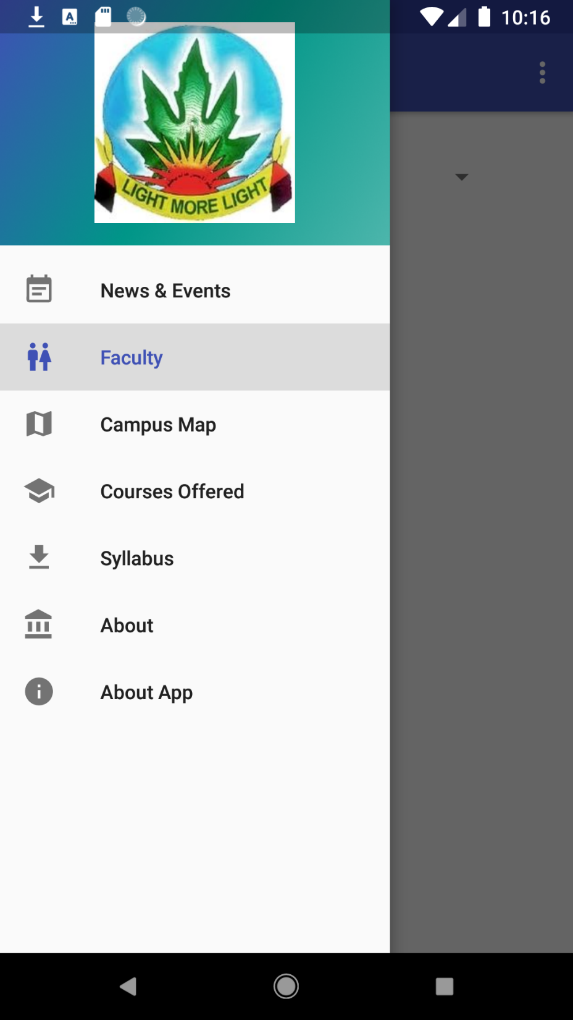

1.2

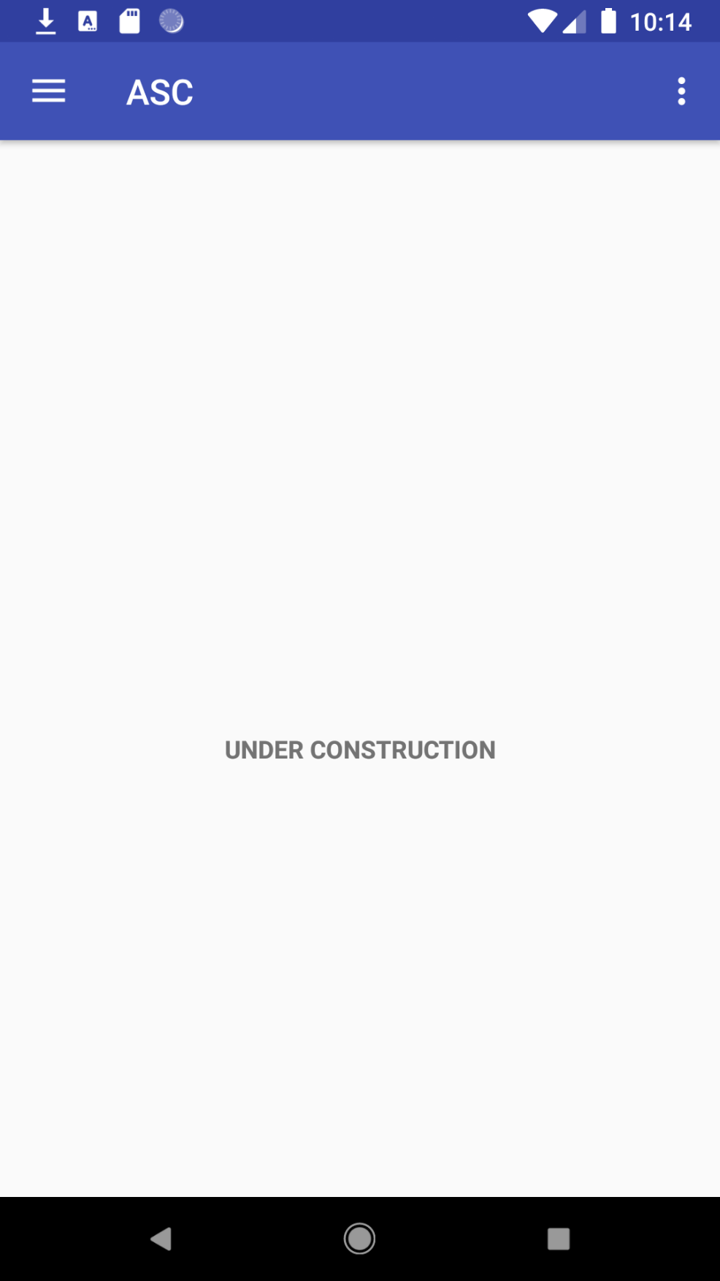

1.3

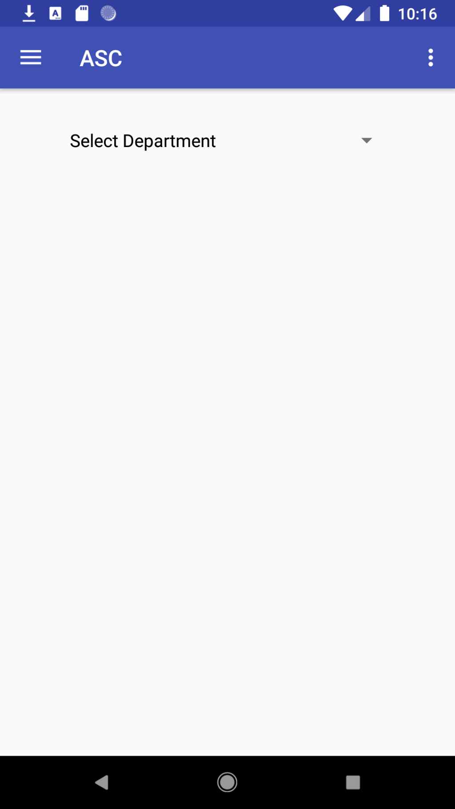

1.4

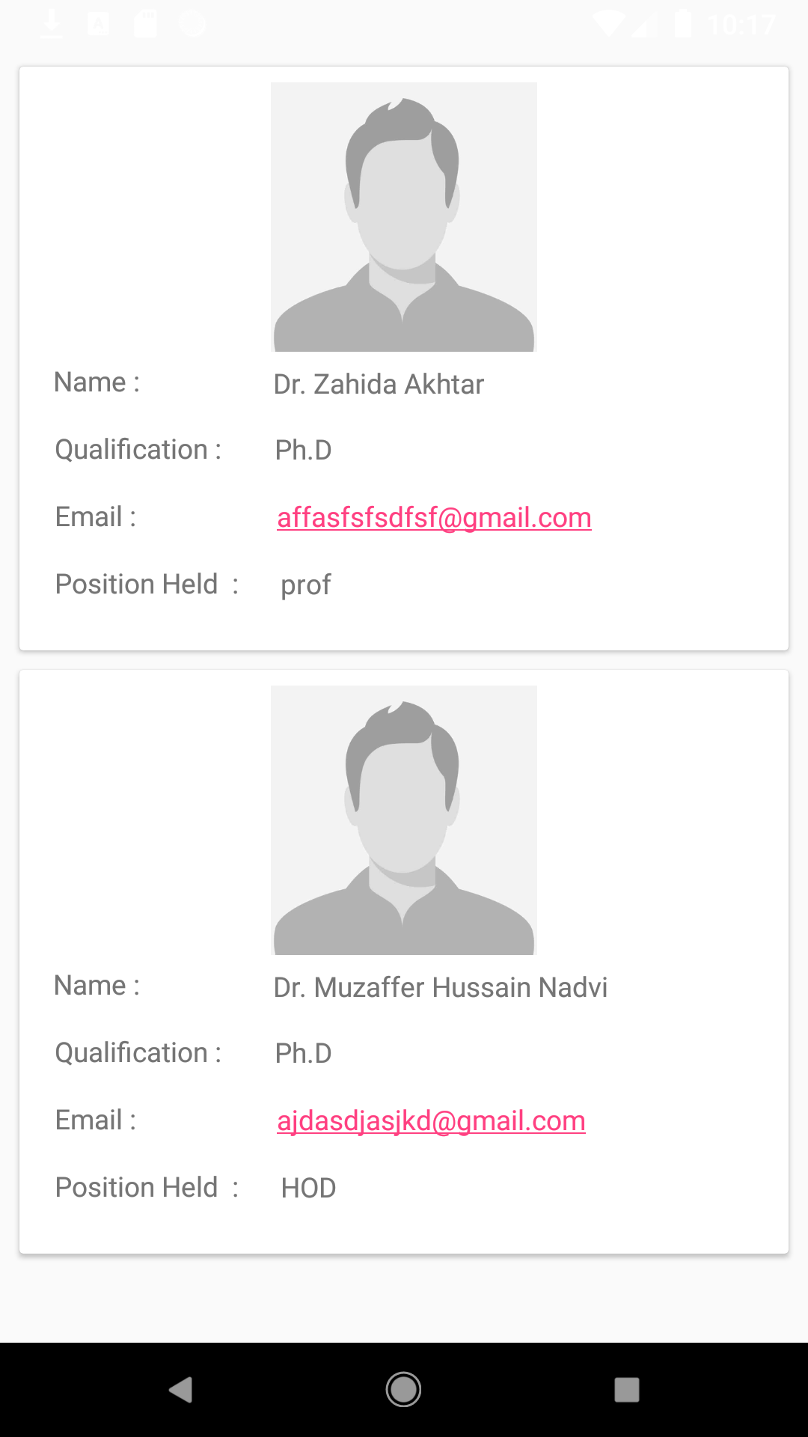

1.5

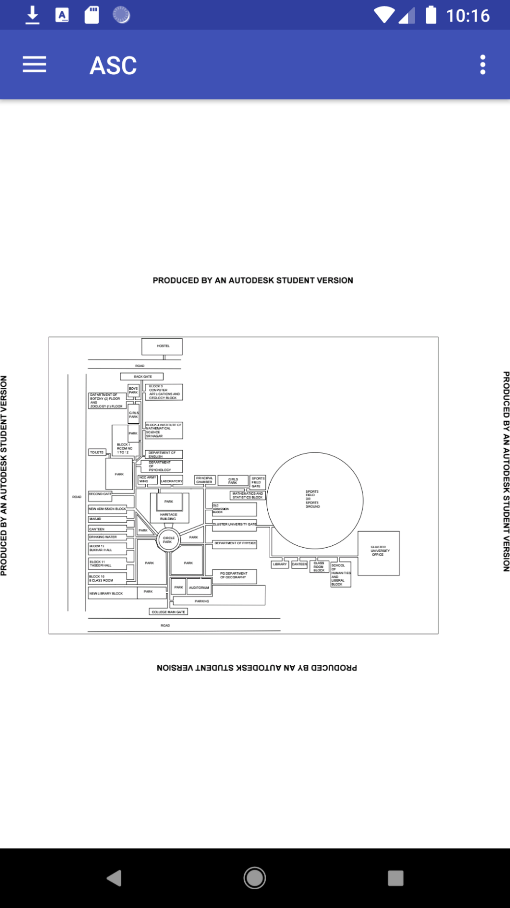

1.6

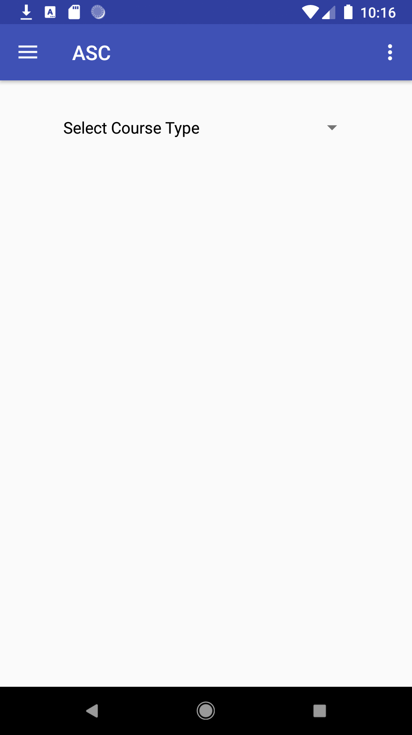

1.7

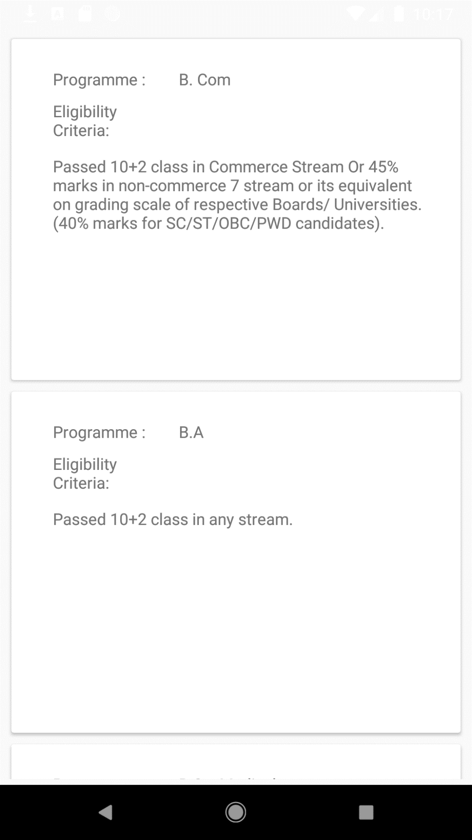

1.8

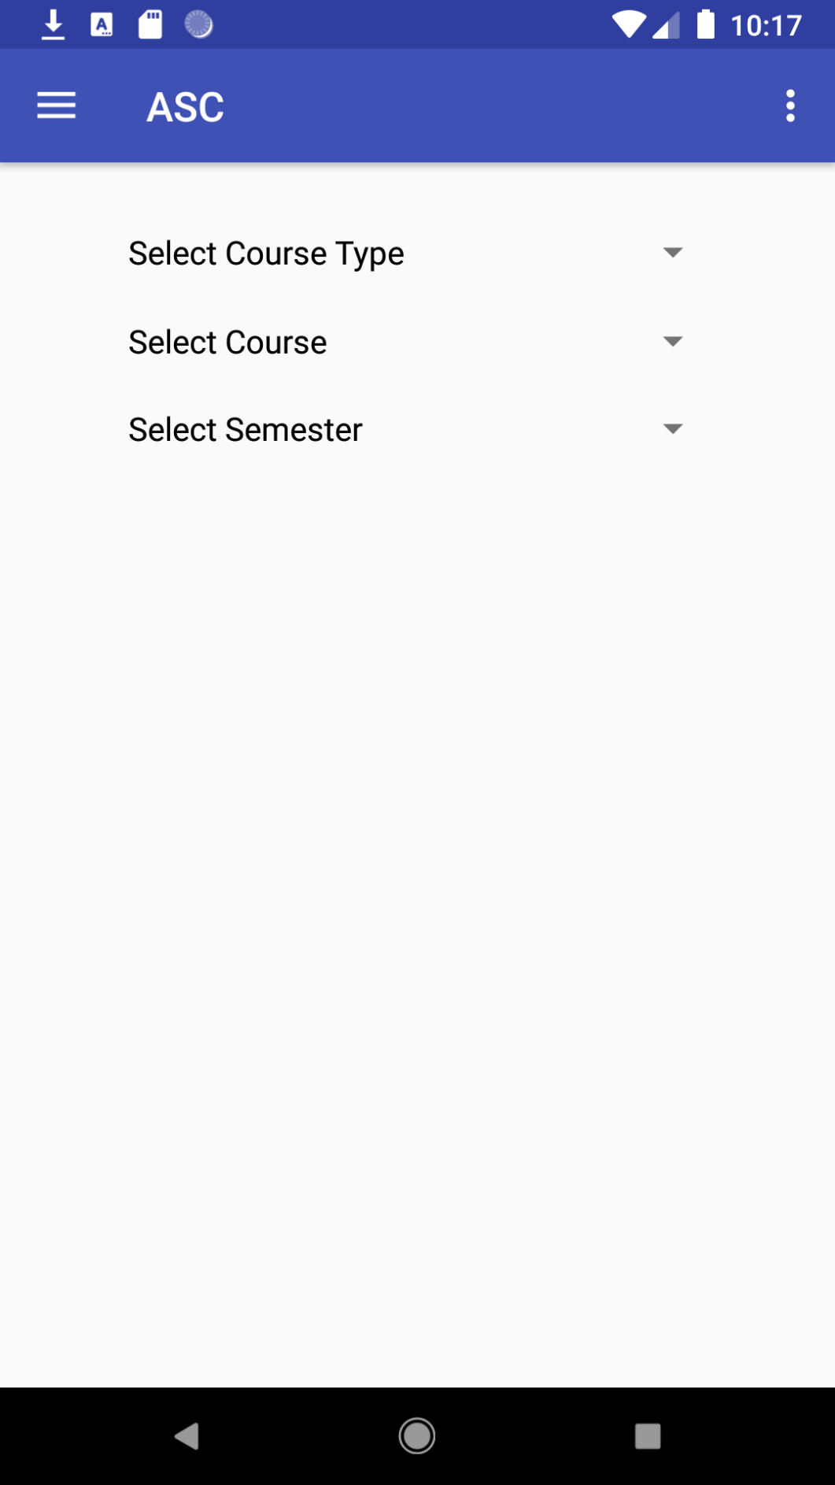

1.9

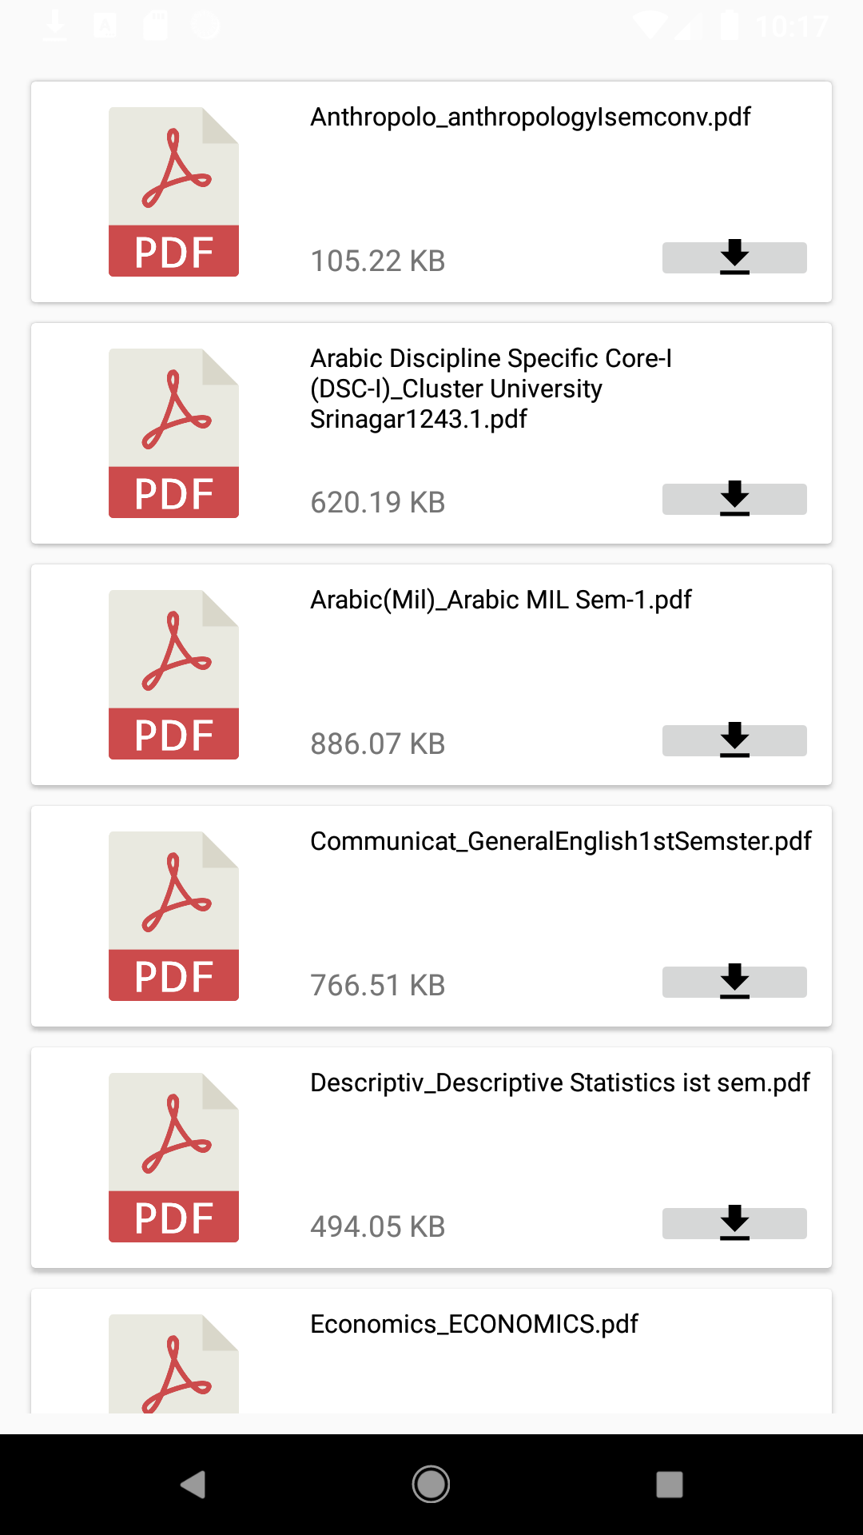

1.10

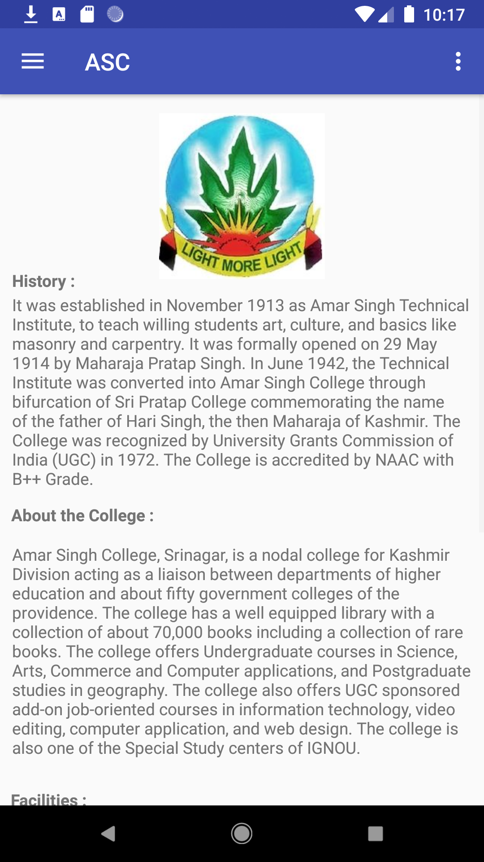

1.11

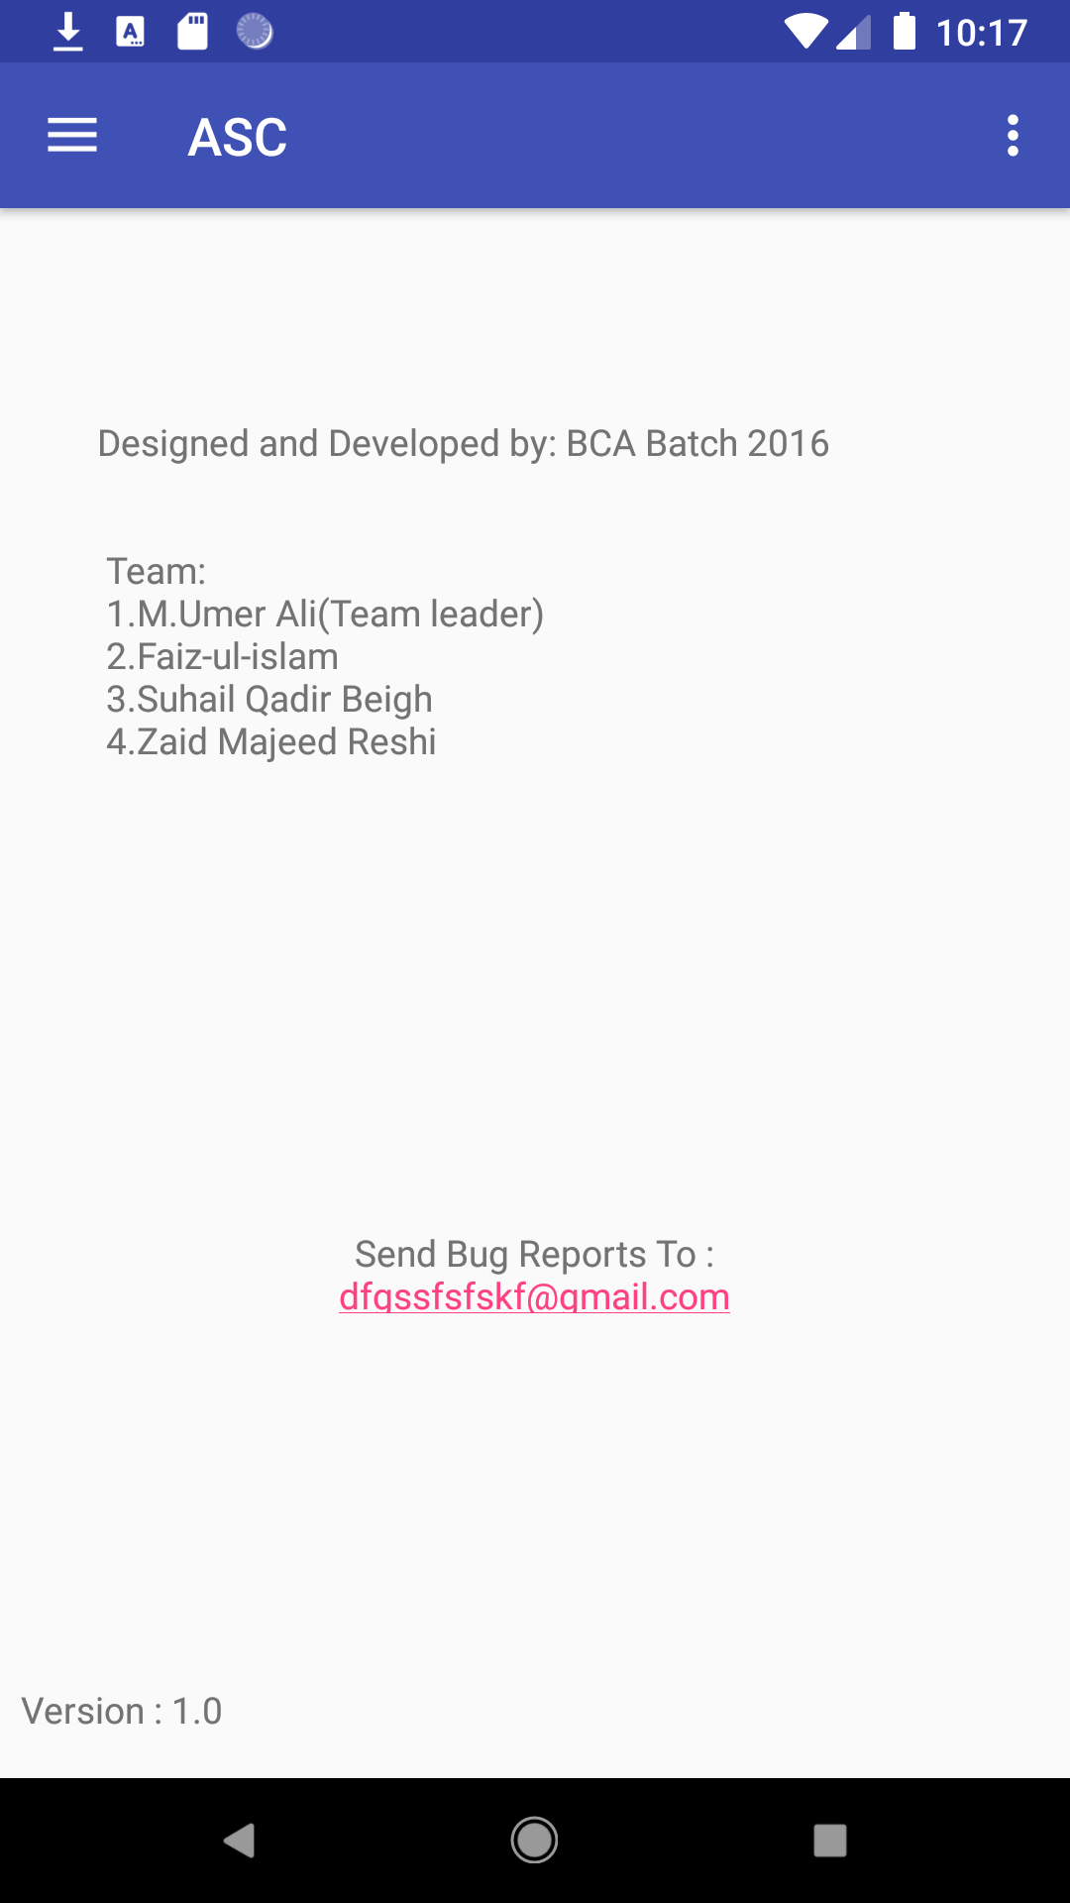

1.12

Database

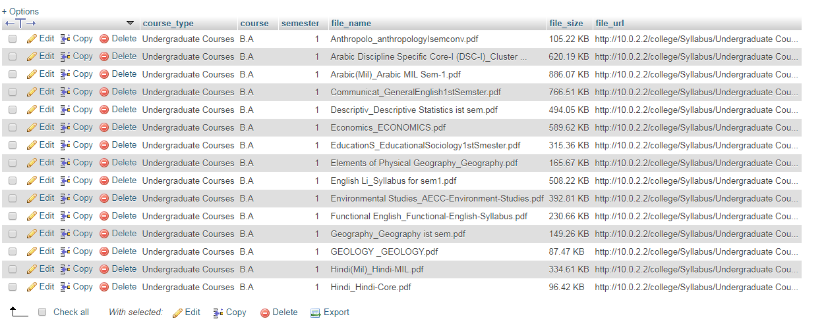

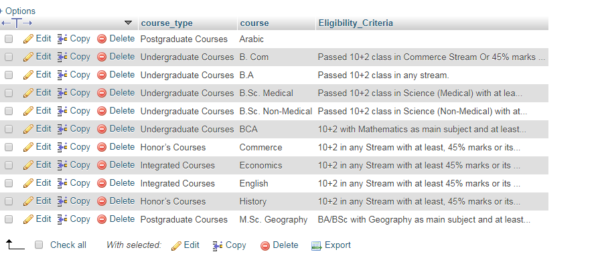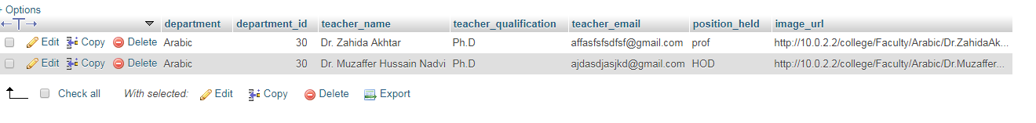

Data Flow Diagram level 0

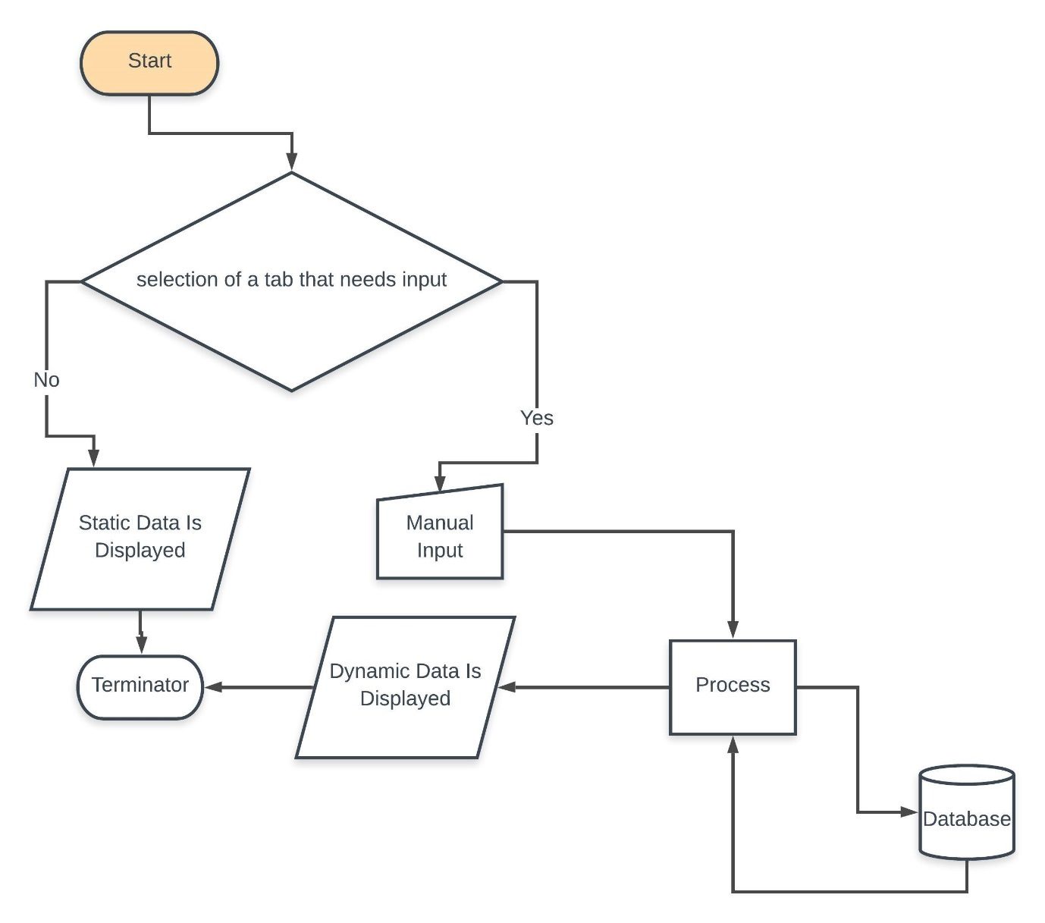

About Developers

1. M.Umer Ali (Team leader). **ROLL NO**: 2553.
2. Faiz-ul-islam. **ROLL NO**: 2561.
3. Zaid Majeed Reshi. **ROLL NO**: 2535.
4. Suhail Qadir Beigh **ROLL NO**: 2510.